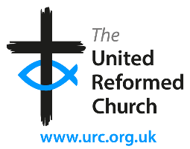

Stockton Road Church News
October 2023

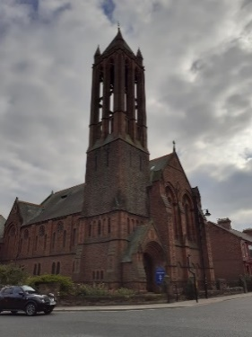
Mark 12: 30-31
“You shall love the Lord your God with all your heart, with all your mind, and with all your strength, and you shall love your neighbour as yourself”.

We are a union of Presbyterian and Congregational churches at the heart of Sunderland city life, growing from a past rich in mission and hospitality. We embrace this heritage utilising the Five Marks of Mission to guide and enable us to take forward current opportunities for mission and service.

Matthew 21:33-46 (Lectionary Reading for 8th – 14th October 2023)
This is Matthew’s third vineyard parable, picking up on the Old Testament metaphor of the vineyard for the people of God. This parable reworks that which can be found in Isaiah chapter 5. While Isaiah focuses on the nation (vineyard) itself, here (as in Matthew’s other vineyard parables: 20:1-16, 21:28-32) Jesus focuses on those working in the vineyard, representing the religious leaders. Jesus’ attack on these leaders is clear. They have ill-treated the ‘slaves’ – the prophets sent by God. They have killed the ‘son’ – a foreshadowing of what will happen to Jesus. They may have worked the vineyard, but we know from Isaiah that its fruit is poor. Now we also know that they have a great disregard for its ‘owner’ – God.
Quoting from Psalm 118, part of the prayer of praise recited when celebrating the Passover, Jesus reminds his hearers of not losing sight of what matters. The cornerstone is that upon which everything else is laid. An alternative translation is ‘keystone’, the stone at the top of an arch that holds everything in place. Either way, losing that stone has awful consequences; such as being crushed by the collapsing structure.
The Passover festival is the ultimate freedom festival, celebrating God’s people set free from slavery, and becoming a people – have they now forgotten who and whose they are? This is a juridical parable: a parable that invites its hearers to pass judgement on themselves as they reflect on their own approach to the ‘vineyard’, to their care for what has been entrusted to them, and to God. Have they – have we – forgotten for whom we are working? Have we become possessive about what we do, or developed a sense of entitlement to what is not ours?
A Prayer
Holy God, Father, Son and Spirit,
creator, sustainer, empowerer, we worship you.
We give you thanks for all that is beautiful:
for all that is fruitful, for all that is lifegiving, for all that is precious.
And we thank you too for entrusting us with the privilege and the responsibility of passing on the baton of your creativity and your ministry of care for all you have made. Amen.

Lectionary Readings October
1 - 7 October - Being open to change your mind
Proper 21: Ezekiel 18.1-4,25-32; Psalm 25.1-9; Philippians 2.1-13; Matthew 21.23-32

8 - 14 October -Taking responsibility for what’s entrusted to us
Proper 22: Isaiah 5.1-7; Psalm 80.7-15; Philippians 3.4b-14; Matthew 21.33-46

15 - 21 October - A wholehearted response to God’s invitation
Proper 23: Isaiah 25.1-9; Psalm 23; Philippians 4.1-9; Matthew 22.1-14

22 - 28 October - What it means to belong to God and others
Proper 24: Isaiah 45.1-7; Psalm 96.1-9,(10-13); 1 Thessalonians 1.1-10; Matthew 22.15-22

29 October – 4 November - How loving God compels us to love others
Proper 25: Leviticus 19.1-2,15-18; Psalm 1; 1 Thessalonians 2.1-8; Matthew 22.34-46

Church Services October

Services at 10.45am in the Sanctuary unless indicated otherwise

Oct. 1st Elisabeth Meikle. Coffee and Croissants in the Lower Hall.
Oct. 8th Christine Hutchinson and Barbara Mitchell.
Oct. 15th Revd Jane Rowell. Harvest Festival.
Oct. 22nd Barbara Ledger.
Oct. 29th Joint Pastorate service at Roker URC. 10.30 a.m.

Our Stained Glass Windows
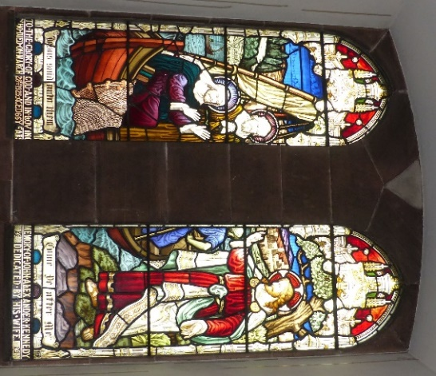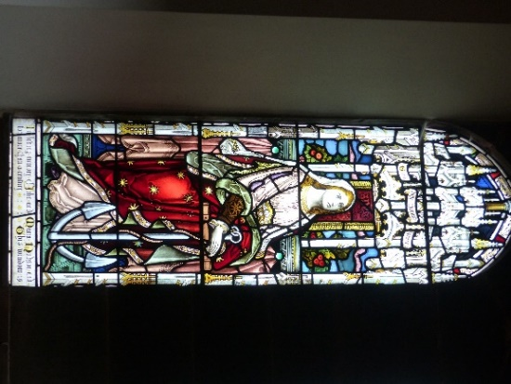
The stained-glass windows are one of the attractive features of Stockton Road. When the building was opened in 1890 the windows were of plain glass, but during the next forty years those in the ground floor of the sanctuary had stained glass installed.
All these windows have Biblical themes and quotations and commemorate members of the Church. The family with most commemorative windows is the Bartrams, the well-known Wearside shipbuilders. They are on the left-hand side when entering the sanctuary. Sir Robert Bartram was the leading light in the construction of our building which replaced the previous St George’s in Villiers Street. Sir Robert did not die until 1925, and does not have a memorial window. Instead, there are three commemorating members of his family who passed away before him – his wife Margaret, who died in 1900, his daughter, also Margaret, in 1906 and his son George in 1910. On the opposite side of the Church, is a window commemorating Alfred Steel who was a member of another notable Sunderland industrial family. Steels

Engineering at Pallion later became famous as the manufacturers of Coles Cranes. Commerce is represented by two windows in memory of the Kennedy family who owned a small department store (formerly Beardall’s) in High Street West. It later relocated to Blandford Street.
Two windows commemorate those most associated with the move of St George’s from the Villiers Street building to our present site. The Rev John Rentoul was the minister in the late 1880s when it was difficult to accommodate all those wishing to hear him preach at Villiers Street and spearheaded the move to build a new church. The memorial window to him and his wife records that their ‘courage and faith enabled this Congregation to build this Church to the Glory of God’. It is fitting that Mrs Rentoul was included in the wording as she wrote about 600 letters to people to help clear the debt incurred in building the Church. On the opposite side of the sanctuary to the Rentoul window is one commemorating John and Martha Meikle (Elisabeth’s great grandparents). John Meikle was the Session Clark and Sunday School Superintendent at the time of the move to Belvedere Road, and gave many years of service to the Church.
Two windows commemorate the Duncan family and, another, Maria Hudson, but I have been unable to establish who they were.
Not all of the windows have the names of the artists/manufacturers. Of those who do, three are by Atkinson Brothers of Newcastle, two by Heaton, Butler and Bayne of London and one each by Powell Brothers of Leeds and Wailes and Strang of Newcastle.
The scenes depicted include Christ as the Good Shepherd and calling his first disciples from their fishing boat and

Christ as the Good Shephard. The most familiar representation is based on Holman Hunt’s painting The Light of the World which sadly was damaged in recent years. Other figures include a knight and, on two separate windows, a female saint in purple with an anchor (above right}. David Whiting was able to identify her as the obscure St Philomena. The story of her death was somewhat legendary; it included being drowned with an anchor on the order of the Emperor Diocletian in the fourth century. As the designs of all the windows on the ground floor were probably chosen from the suppliers’ existing designs, one wonders if the anchor was seen as representing Sunderland’ maritime connections rather than any commemoration of the Saint,
The large windows above the gallery were dedicated in 1921 to the 23 men from St George’s who died in the First World War and have the Biblical themes of Victory and Peace.
The four windows in the vestibule, with symbols from the book of Kells representing the four gospel writers, were installed in 1990 to commemorate the centenary of the building. They were designed by Nicola Hughes and used Sunderland Glass.

Neil Sinclair

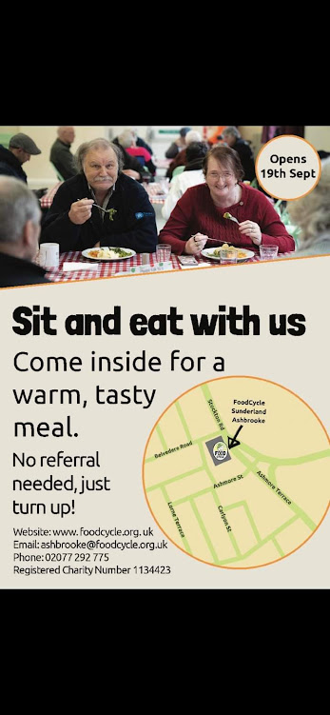

Check website for more information and equipment safety sheet.www.loveamelia.org.uk

