Stockton Road Church News
June 2023

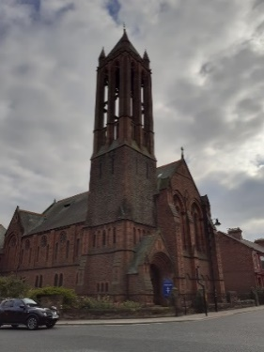
Mark 12: 30-31
“You shall love the Lord your God with all your heart, with all your mind, and with all your strength, and you shall love your neighbour as yourself”.

We are a union of Presbyterian and Congregational churches at the heart of Sunderland city life, growing from a past rich in mission and hospitality. We embrace this heritage utilising the Five Marks of Mission to guide and enable us to take forward current opportunities for mission and service.

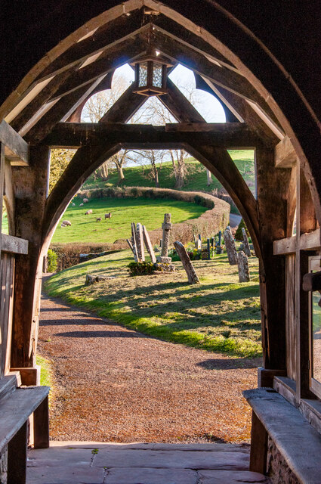
Thinking Allowed
The Porch
RS Thomas
Do you want to know his name?
It is forgotten.
Would you learn what he was like?
He was like anyone else,
a man with ears and eyes.
Be it sufficient that in a church porch on an evening in winter,
the moon rising, the frost sharp,
he was driven to his knees
and for no reason he knew.
The cold came at him;
https://www.geograph.org.uk/photo/6794879
his breath was carved angularly as the tombstones;
an owl screamed.

He had no power to pray.
His back turned on the interior
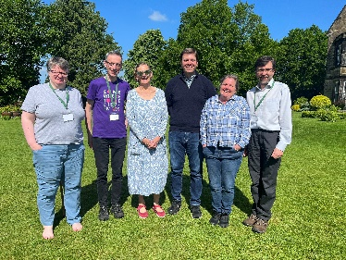
he looked out on a universe that was without knowledge of him and kept his place
there for an hour on that lean threshold,
neither outside nor in…

I write this month’s piece having spent most of this week at The Hayes Centre in Swanwick Derbyshire at the annual Minister’s school. This is a time to take a breath, to catch up with colleagues and friends, but also a time to be challenged, to pray and to listen for God’s voice.

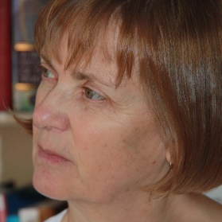
Our session leaders were Carla Grosch – Miller, who many of you will have encountered through her Ministries in this Synod or her thought provoking reflections. I have some of her books if anyone would like to borrow them.
Our second session leader was Elizabeth Baxter from Holyrood House and an Anglican Minister.
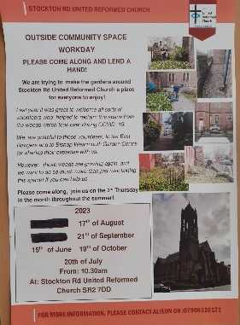
In the session Elizabeth led, which she titled Pentecost, she shared the poem above. Many of you may know R S Thomas as a Welsh poet and
an Anglican Minister but I didn’t!

For me though this poem felt very relevant to where we are at Stockton Rd United Reformed Church. When we began our Garden Project with our ‘Hopes and Dreams’ session back in February 2022, we heard that people in our local community thought we had closed and the building was empty.

Personally, I know that perception has changed through all of our hard work over this last year. We have chatted to people as we have completed our community gardening sessions. This year I have had a few people just popping in as they are passing, which shows us that people are again see us as being there for them. Perhaps that new sense of presence is reflected in the trickle of people who are now beginning to come along on a Sunday?

Some of those individuals came to mind as I read this poem. Some of those individuals came into our building, because they volunteered, some straight to worship, but in the culture of our society today that is not always easy, maybe even alien. This meant that I, personally, found this poem resonated quite powerfully with me as we journey to make our building a thriving community hub.

I would love to hear what you think of this piece? For me, this person is searching, yearning even, for God, but it is too hard to cross the threshold into the church building. This liminal, in between place, here the porch, could make it possible, as could relationships, conversations, us being there. However, the yearning in this piece reminds us that this will not happen quickly, or in our own time, but rather in theirs and God’s time. We need patience and perseverance in a world that is very different to when each one of us crossed over a threshold into this building, a church we have made our home probably because of those we encountered and the welcome we received.

This reminded me of the guest speaker at my Induction here who spoke about the importance of ‘Presence’ for me, for us and the work we are attempting. Someone from the church needs to be there when people need them to be, not necessarily when it suits us. However, that ‘Presence’ does not necessarily need to be me alone, each one of us can come alongside people as a welcoming presence, as an acquaintance, perhaps in time maybe as a friend.
As our work has progressed, we have and are continuing to form partnerships which enable new opportunities for that presence, but to enable this work to last after I retire, or the CRCW Project ceases I/we need you to get involved, to be the church’s ‘presence’ at the groups and events that are coming into being. I hope each and every one of you feel able to help in that way. After all you as a church community have such a rich history of hospitality, service and mission!

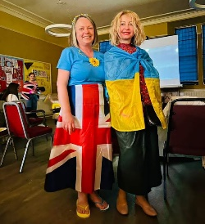
This was so evident at the Eurovision celebration that we supported the informal group, Sunderland for Ukraine, to host. There were half a dozen of us there to celebrate with the hosts, families and friends. I found it an honour to celebrate with them, to hear their stories and help them to feel wanted in this terrible time. Perhaps one of those who were there will write a short piece for the newsletter to share their experience, but for now they noted our presence, were so grateful, and, I feel, we gained as much as they did.
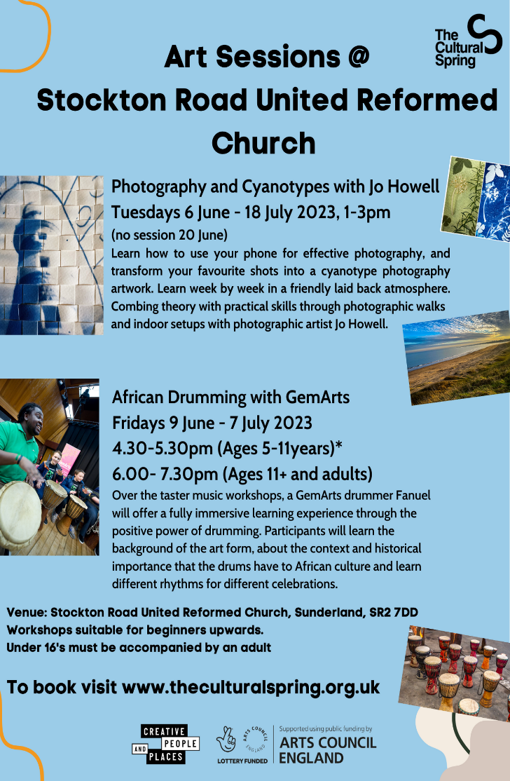
The new sessions with The Cultural Spring begin this week, this time 5 or 6 weekly blocks. Please book a place and come along and actively share the children and family drumming sessions with any children you know, your children and grandchildren. Invite them along and maybe join in yourself, Dave and I plan to be there!

We are continuing to work towards opening our building with four days of events to encourage ourselves and others to celebrate and explore our glorious home, all of the buildings which make up Stockton Rd United Reformed Church.
- Currently we are working with The Cultural Spring to design and create a piece of stained-glass art with input from our current building users so we hear what the building means to them. This is another benefit of the partnership work we began with The Cultural Spring last year.
- We hope to hold a service on a meeting night to dedicate and then install the banner we created with the Rainbows last year. It would be lovely if some of us could join in with that.
- There will be one of our Community Workdays on the first day, the 17th of August, and a guest speaker in the evening.
- We hope the building will be open during the day on the Friday, 18th of August, and we hope a Nigerian social event in the evening.
- Our activity day for all will be coordinated with a theme of ‘Our heritage, our environment ‘on the Saturday 20th of August. We have lots of stakeholders to lead activities, but we will need to have our own volunteers to make this happen so speak to Anne Lewis if you can help
- Then on the Sunday Jane will lead our worship with an environmental theme, followed by a light buffet lunch and entertainment from the dance school. We will invite the carers and performers to share lunch with us.
Then in September we are hoping to start a community lunch utilising food otherwise destined as landfill in partnership with a national organisation, Foodcycle depending on the decisions reached at our next Church Meeting on the 20th of June at 3.00pm, it would be good

to see you there.

Exciting, busy and, I hope, not too exhausting times ahead,

Every blessing,
Alison Dalton,
Church Related Community Worker
07908110121 crcw.alison.dalton@gmail.com

Lectionary Readings
4 to 10 June – Matthew 28: 16-20; 2 Corinthians 13:11-13; Genesis 1:1-2; Psalm 9.
11 to 17 June – Genesis 12:1-9 and Psalm 33:1-12; Hosea 5:15 to 6:6 and Psalm 50:7-15; Romans 4:13-25; Matthew 9:9-13, 18-26.
18 to 24 June – Genesis 18:1-15; Psalm 116:1-2, 12-19; Psalm 100; Romans 5:1-8; Matthew 9:35-10:8, (9-23).
25 June to 1 July – Genesis 21:8-21; Jeremiah 20:7-13; Psalm 69:7-10, (11-15), 16-18; Romans 6:1b-11; Matthew 10:24-39.

Church Services June

All services at 10.45 am in the Sanctuary unless indicated otherwise

June 4 Coffee and croissants (lower hall)

June 11 Elisabeth Meikle

June 18 Revd Jane Rowell

June 25 Barbara Mitchell and Christine Hutchinson

Scheduled Meeting

Church Meeting Tuesday 20 June at 3pm

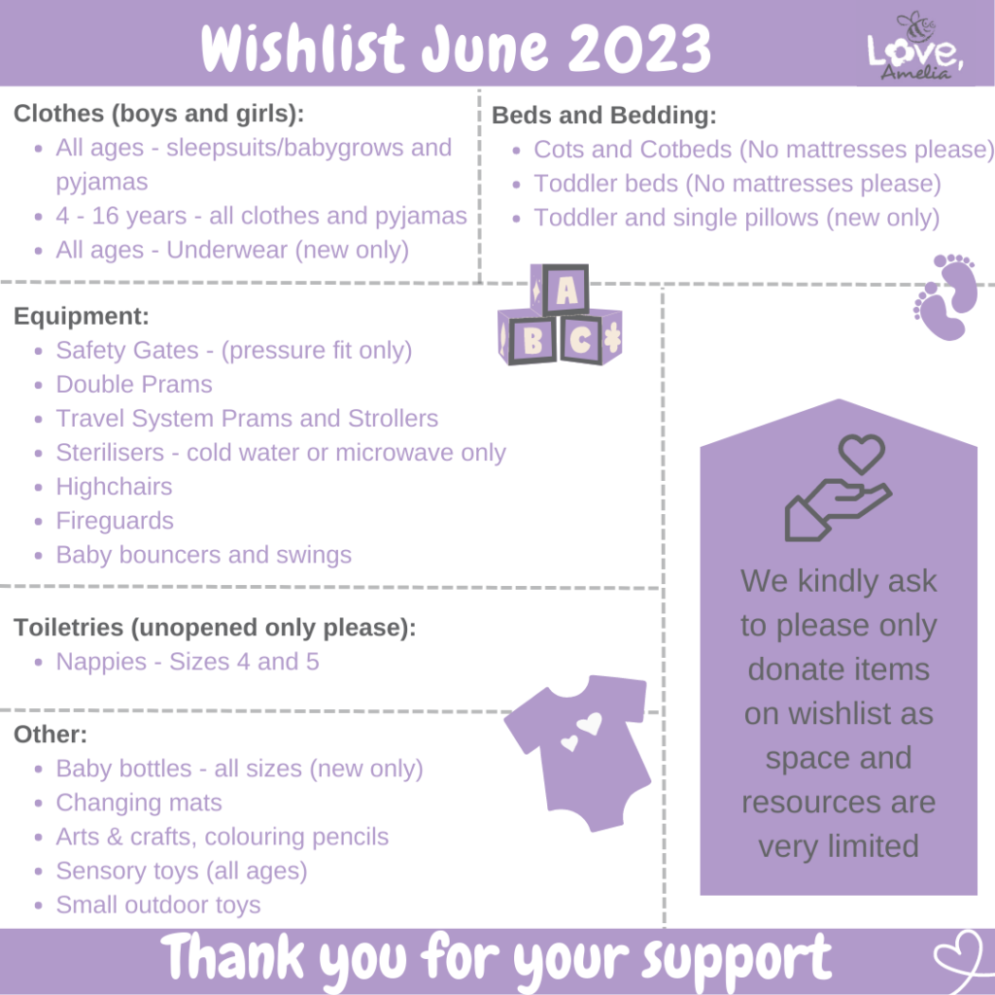
Check website for more information and equipment safety sheet.www.loveamelia.org.uk

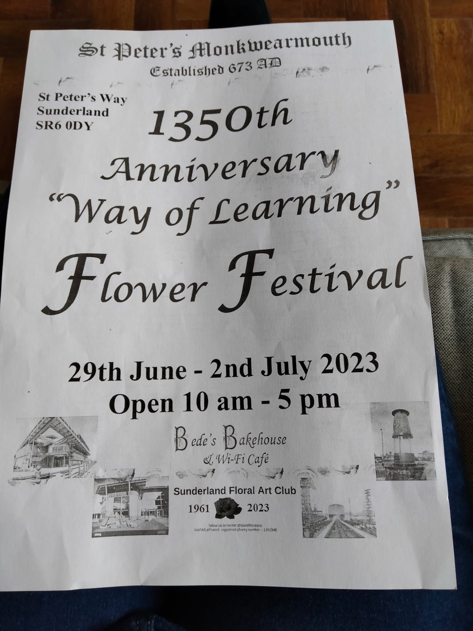

Copy for July Newsletter by 25 June to rosina.anderson1503@ntlworld.com please

