

Stockton Road Church News
April 2023

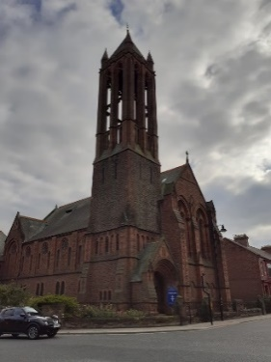
Mark 12: 30-31
“You shall love the Lord your God with all your heart, with all your mind, and with all your strength, and you shall love your neighbour as yourself”.

We are a union of Presbyterian and Congregational churches at the heart of Sunderland city life, growing from a past rich in mission and hospitality. We embrace this heritage utilising the Five Marks of Mission to guide and enable us to take forward current opportunities for mission and service.

Christos anesti! Alithos anesti!

A greeting you hear all over Greece (and with Greek speaking folks across the globe) on Easter Sunday!!

Christ is risen, he is risen indeed!!!

This is a greeting full of joy and hope – Christ is risen! He IS risen indeed – Alleluia!!!

However, you may be reading this before Easter Sunday and so we have Easter week to encounter first… before the alleluias of Easter we have the remembrance and betrayal of Maundy Thursday, the pain and agony of Good Friday and the desolation and emptiness of Holy Saturday.

It is in going through, remembering, encountering these days that we can truly understand the power of Easter Sunday!

It’s in the eating together on Maundy Thursday, remembering his words – this is my body, my blood; in the watching as Judas betrays with a kiss, that we can truly understand the power of forgiveness and the power of the cross, standing empty.

It’s in the hearing again of the story of Good Friday, of cocks crowing, of tears of a denial, of the whipping and beating, of the humiliation of carrying a cross through the streets, in the hammering of nails into flesh and being mocked and tormented that we can truly understand the power and depth of God’s love for us.

It’s in the desolation of the tomb, the empty feeling of grief, the wondering ‘what now?’ of Holy Saturday that we truly understand the wonder and joy of an empty tomb.

It’s in the shock of meeting Jesus in the garden, the saying of a name, the running of disciples to share the news that we are truly encouraged to go out into the world and declare

Christos anesti! Alithos anesti! Christ is risen! He is risen indeed!!!

Alleluia!!!!!

Happy Easter dear friends
Blessings and love
Jane

Lectionary Readings
April 2 Psalm 118:1-2,19-29; Matthew 21:1-11
April 9 Acts 10:34-43; Psalm 118:1-2,14-24; Colossians 3:1-4; John 20:1-18 or Matthew 28:1-10
April 16 Acts 2:14a, 22-32; Psalm 16; 1 Peter 1:3-9; John 20: 19-31
April 23 Acts 2; Psalm 116; 1 Peter 1; Luke 24
April 30 Acts 2:42-47; Psalm 23; 1 Peter 2:19-25; John 10:1-10

Church Services April



From Easter Sunday all services at 10.45 am in the Sanctuary.

April 2nd Elisabeth Meikle. Coffee and Croissants in Lower Hall.
April 6th Revd Jane Rowell. 12pm Maundy Thursday lunch and Communion. Please contact Gwennyth Gibson (0191 5674392) if you wish to come.
April 7th Revd Jane Rowell. Good Friday Drop-in with prayer stations and reflection areas. 3-4pm in the Sanctuary.
April 9th Easter Sunday. Barbara Ledger. Communion service.
April 16th Revd Jane Rowell.
April 23rd Revd Dr David Whiting.
April 30th Revd Jane Rowell. Joint Pastorate service at St Margaret’s South Shields. 10.30 am.

Easter Walk of Witness
After a break of 3 years the Easter Walk of Witness at Tunstall Hill will take place on Good Friday, April 7th. The event starts at 10am with the cross erected on the hills followed by a short service at 10.30am.
If you require any further information please contact Barbara Mitchell.

Heritage Project
As last year’s Church heritage event proved successful, the Church Meeting approved the proposal from the Heritage Working Group that there should be another heritage community event this year. It will be held on 4th and 6th-9th July.
The main focus will be on Saturday 8th July which will be a family friendly funday on the theme of heritage and environmental issues. Some of the activities will take place in the Church Garden, taking advantage of the good work that has recently taken place there.
Other matters discussed at the Group were the repair of the damaged stained-glass window, an inventory of historic artefacts, documents and photos (see below) and an oral history project to record the memories of church members.

Heritage Inventory

Recent work on the Church has meant that cupboards have been emptied, revealing documents, photos and items such as 19th century collecting boxes for the Presbyterian Church’s China Mission in China. A few of these were displayed at the last heritage event, along with banners paraded at the Good Friday Sunday School procession.

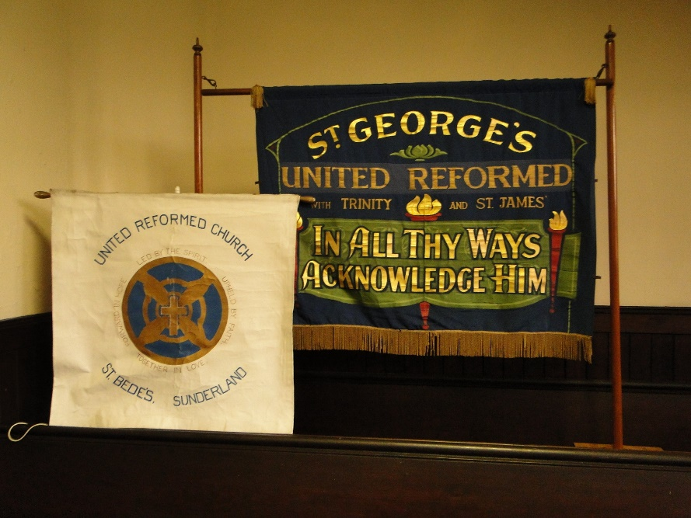

A start is going to be made on an inventory of our historic items so that we know what we hold, and the origin of the objects (they come from at least seven different buildings).
Help will be needed for the project to. If you can assist, please speak to me at Church or contact me on 0191 5110452 or on neil.sinclair83@ntlworld.com
Neil Sinclair



Check website for more information and equipment safety sheet.www.loveamelia.org.uk

St Cuthbert’s Centre Holy Island Visit
Wednesday 17 May 11am – 5pm

You are invited to ….
Come, rest a while and “be” ….



Holy Island Events 2023



(double-click on PDF links to open)



Thinking Allowed

Matthew 9:35-38

(New Revised Standard Version, Anglicised)

The Harvest Is Great, the Labourers Few
³⁵ Then Jesus went about all the cities and villages, teaching in their synagogues, and proclaiming the good news of the kingdom, and curing every disease and every sickness. ³⁶ When he saw the crowds, he had compassion for them, because they were harassed and helpless, like sheep without a shepherd. ³⁷ Then he said to his disciples, ‘The harvest is plentiful, but the labourers are few; ³⁸ therefore ask the Lord of the harvest to send out labourers into his harvest.
I wonder why this Bible reading came to mind when I began to think about composing this piece? I guess it will be OK for us to explore that together as I’m sure Jane’s piece will be focussed on Easter and the usual events we remember in the Christian calendar at this time of year.
Once again, the reading has a farming focus, but I guess as the Jewish economy of this period was agrarian and so farming stories would be understood easily by those listening?
For me the first part of this reading is as important as the last couple of verses, but it is verse 37 that comes to mind more easily as it is often taken as the focus when this reading is explored by preachers. In the early verses we hear that Jesus is out and about, exploring ideas sometimes in the Synagogues, sometimes elsewhere, sometimes teaching but often trying to help too. As I mentioned last month though in this reading, even though it is not said explicitly, perhaps there is a sense of weariness in verse 37 ‘Then he said to his disciples, ‘The harvest is plentiful, but the labourers are few;’ and that resonates with where we are as churches today. However, I wonder if we should turn that around because of verse 38 where we are entreated to ask God for help and the suggestion that help will come.

For me currently it feels that is where we are at Stockton Rd United Reformed Church, we have so much goodwill being shared with us, and help is being offered both to us and from us to others.
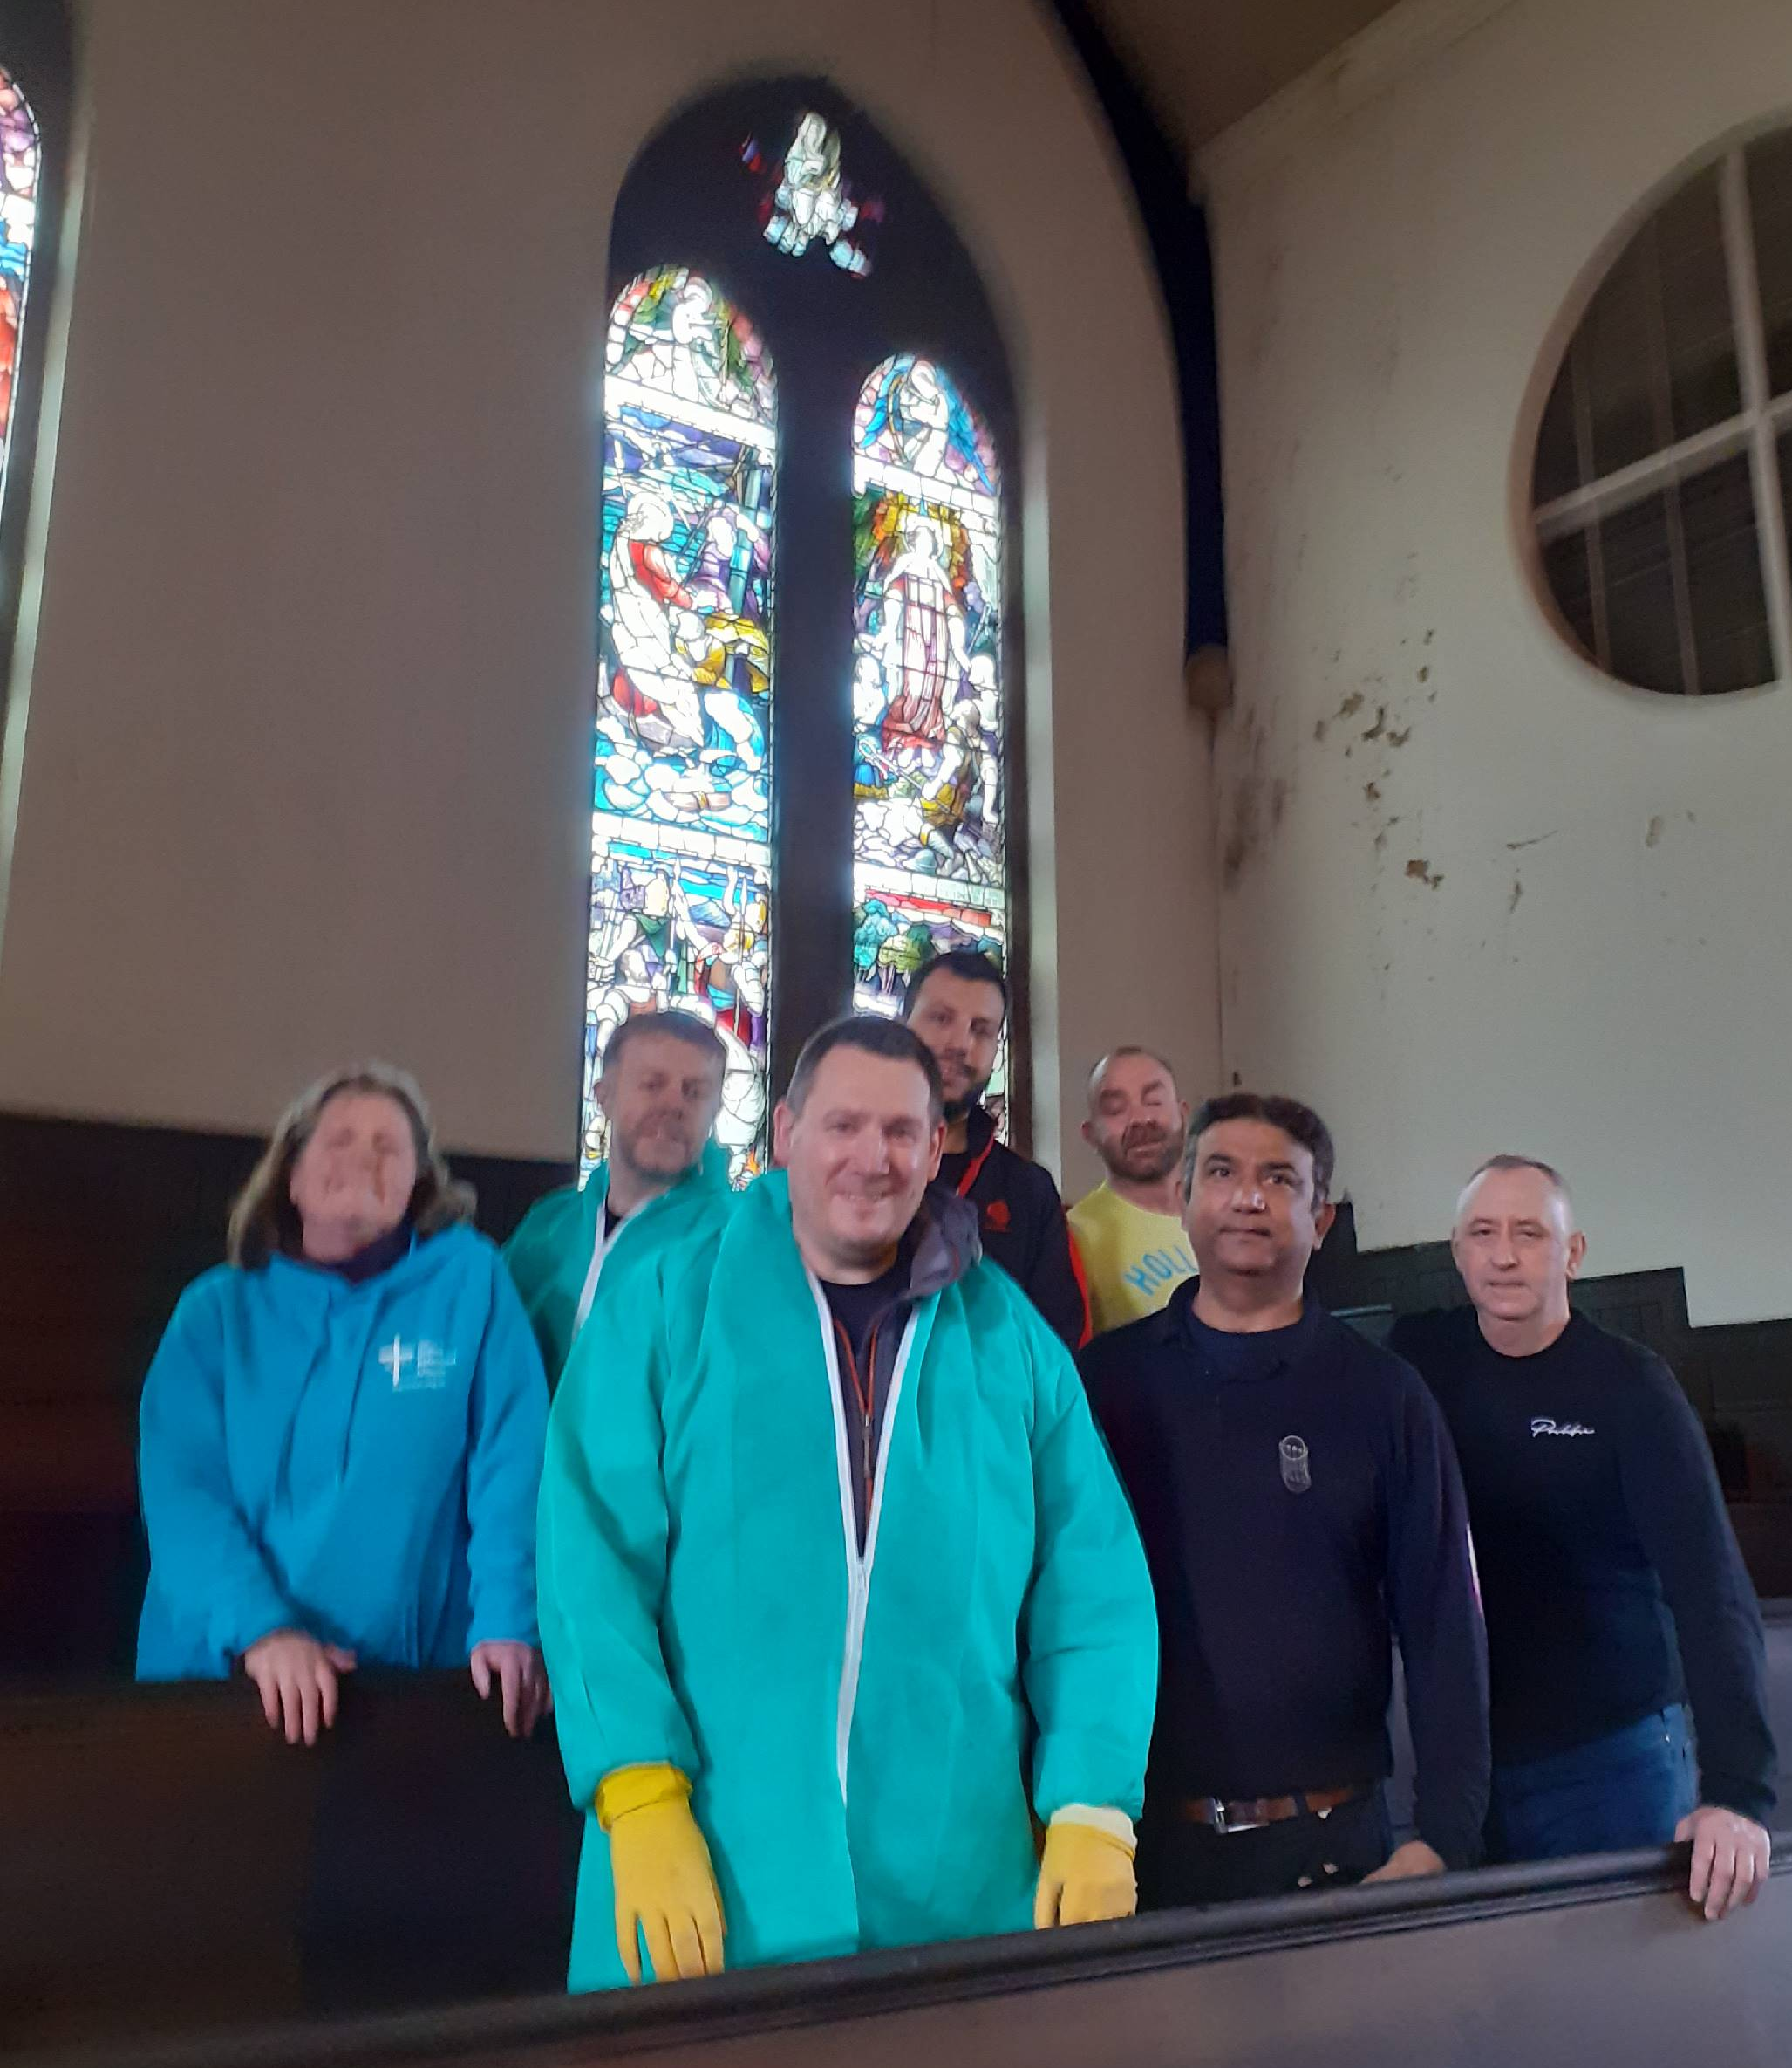
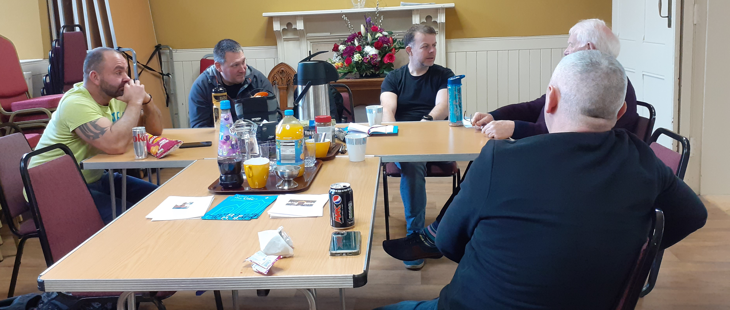
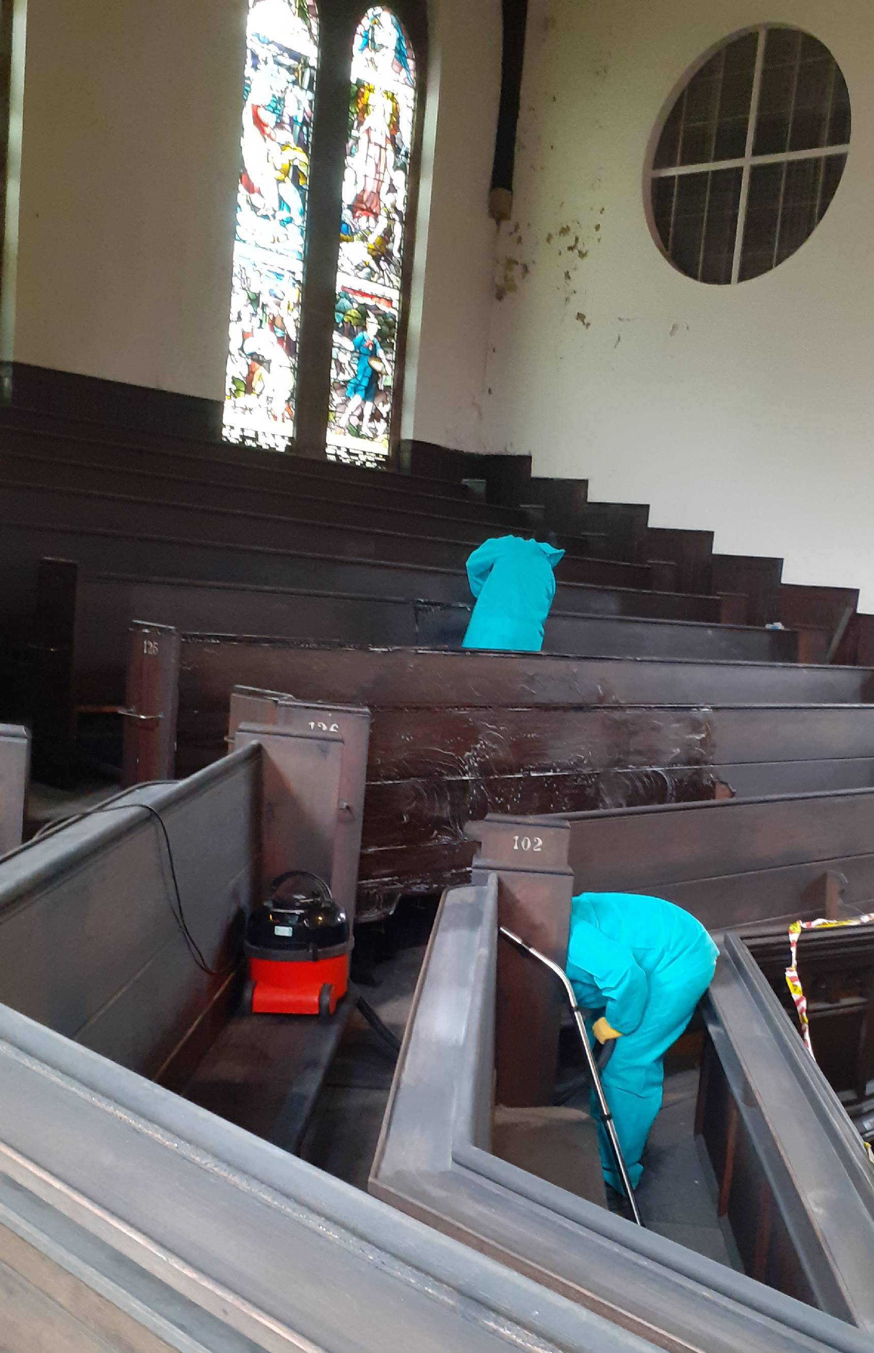
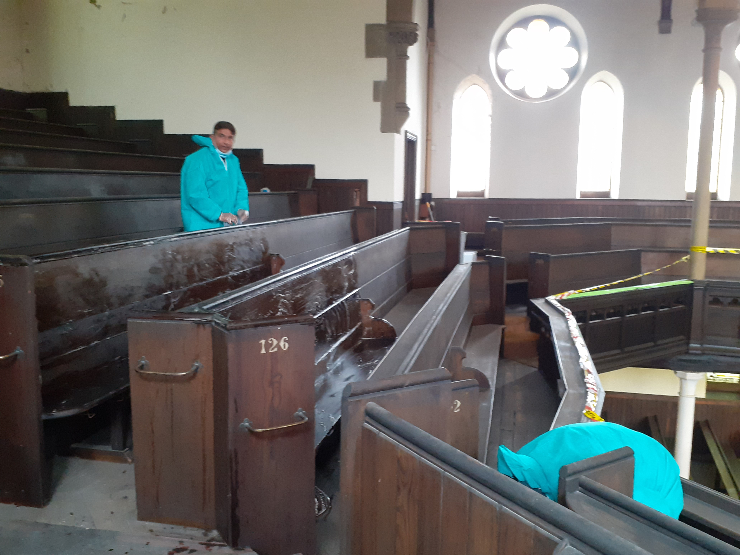
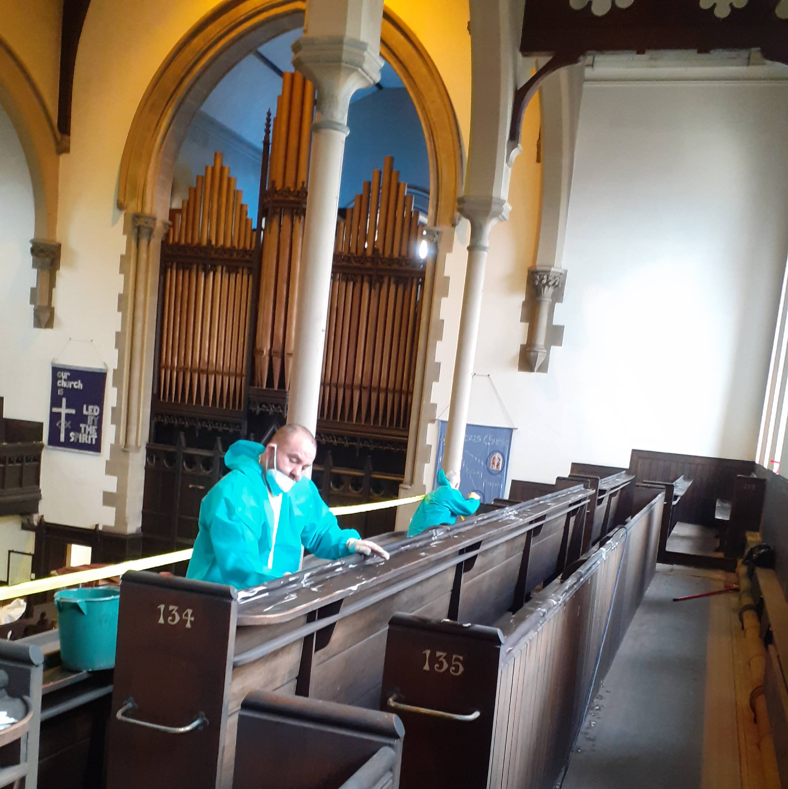
A couple weeks ago a team of wonderful men came from Nissan to clean the gallery for us. They were lovely folk, blown away by this glorious building, who went the extra mile to do all that was asked. Perhaps when you are in the building next pop up and look. For me, this is exciting because if we open our building again as part of our heritage project, we can take them up to the gallery and you can see the true majesty of this amazing space! ‘therefore ask the Lord of the harvest to send out labourers into his harvest’ When chatting with them all at different times during the day, a couple of them said they were going to ask back at work if Nissan could support us in some way. Another lives in Argyll Square and said he may pop in on a Sunday, yet another was telling us his memories of coming here as a child and David blessing his wedding back in 2017. All of them asked if we managed to source and or buy some wax to nourish the wood on the pews up there, which are now noticeably dry, if they could come back to help with that. Once again it was awesome to see what goodwill there is for us and how much people love this very special place.
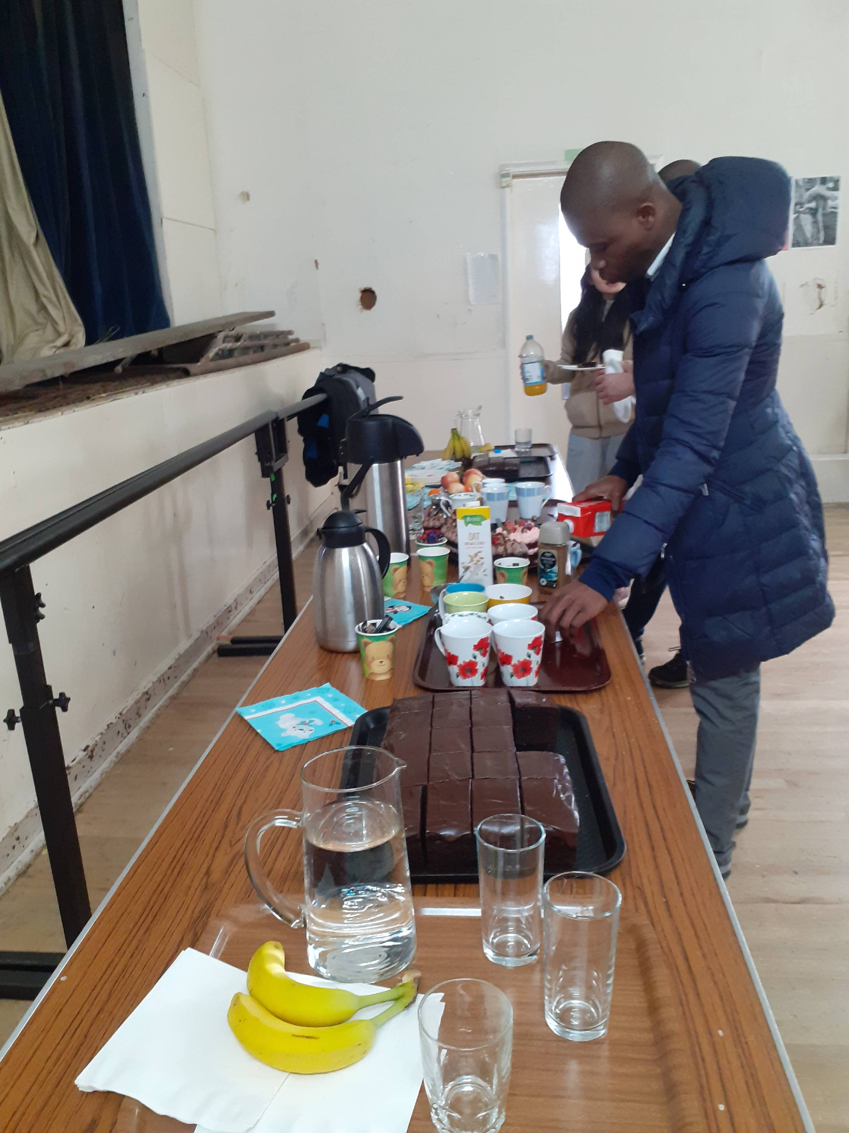
Last week we helped ICOS out as they were expecting a group of 20 University Students to go bird watching at Rainton Meadows and litter picking in Backhouse Park followed by exploring ways they could recycle under a gazebo in the park. Then there was a severe weather warning, storm Otto was on its way, so within 24 hours we enabled them to use the upper halls instead of a gazebo and once again people loved the building and were very grateful, plus the Recycling officer from Groundwork North East has volunteered to come along and share ideas with us if we would like to invite her. Hopefully the Gardening project will look at that offer when we meet during March.
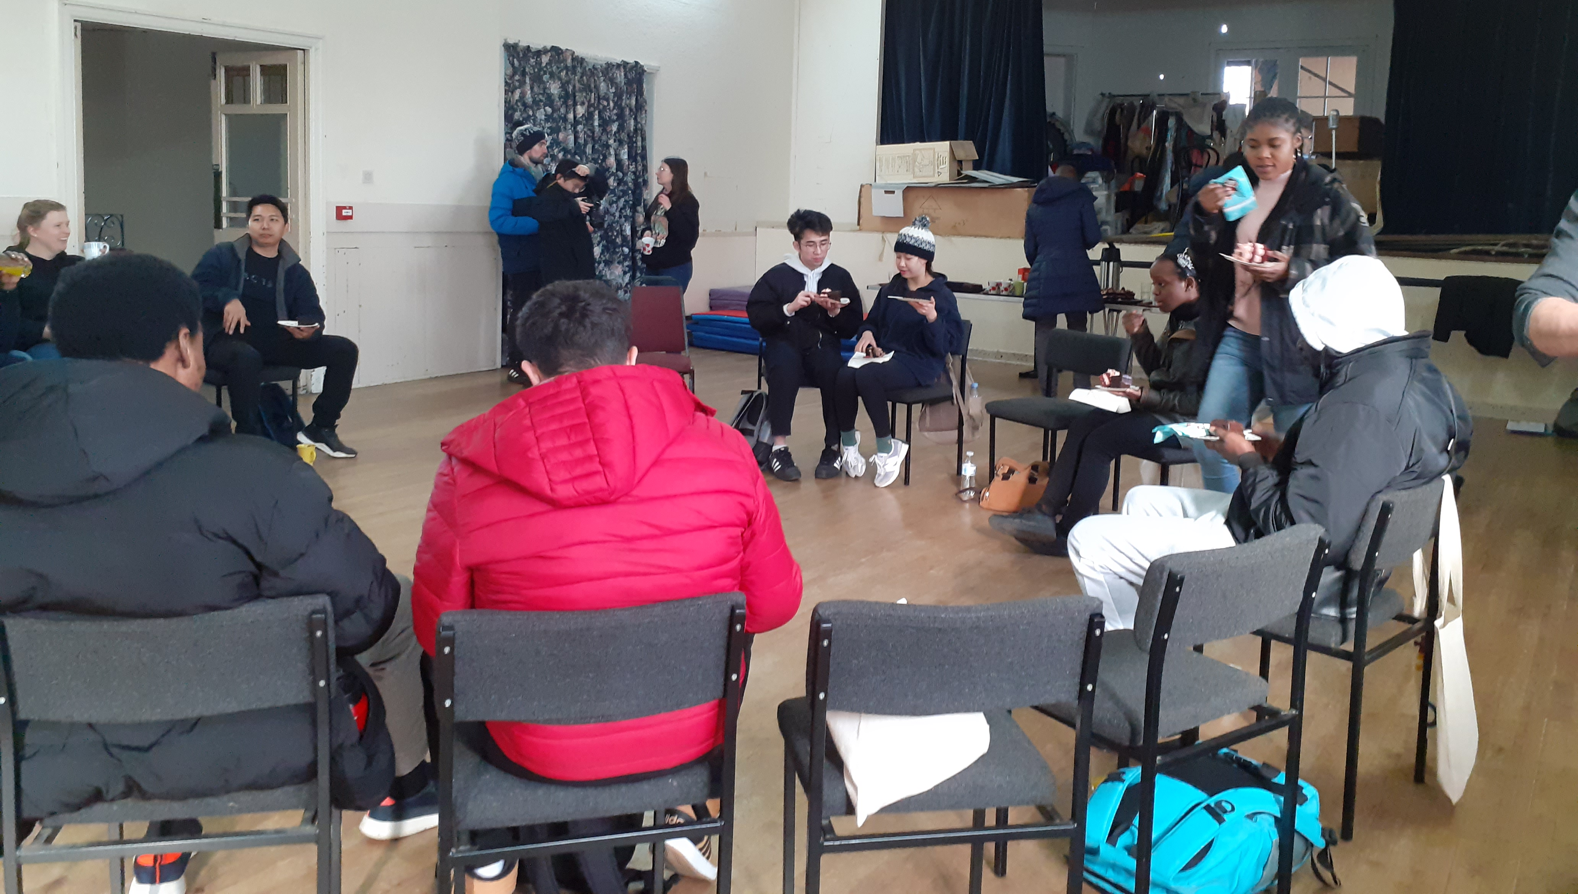
This reminds me of something that Steve, an officer with VCAS, says to me often…’You have to kiss a lot of frogs to find your frog prince!’
I continue to show lots of people around our building and hope we can develop partnerships in time, but we want the right partnerships which our recent Visioning Day was very helpful to me as it showed me your thinking, your priorities which I hope the CRCW Project Steering Group will help us take further.
And a reminder that Love Amelia are still asking for things on their website, see March Wishlist on page 7.
Thank you for allowing me to join you on this wonderful journey.

Every blessing
Alison Dalton,
your
Church Related Community Worker
07908110121 crcw.alison.dalton@gmail.com

Copy for May Newsletter by 23 April to rosina.anderson1503@ntlworld.com pleas

