

Stockton Road Church News
January 2023

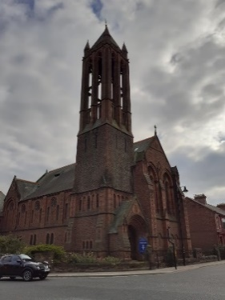
Mark 12: 30-31
“You shall love the Lord your God with all your heart, with all your mind, and with all your strength, and you shall love your neighbour as yourself”.

We are a union of Presbyterian and Congregational churches at the heart of Sunderland city life, growing from a past rich in mission and hospitality. We embrace this heritage utilising the Five Marks of Mission to guide and enable us to take forward current opportunities for mission and service.

Happy New Year 2023

Letter from our new Minister, Jane Rowell
Dear friends,

Firstly, I must say a big thank you to you all for calling me to be your new minister! I’m looking forward to getting to know you all and working with you!

I thought I’d write this to say hello to you all, to bring Christmas greetings and to reflect a little on Christmas, New Year and the future.

Christmas is about celebrating the birth of all things new, the birth of a baby who will bring to new life to a worn and weary world, the birth of hope, the birth of love and joy anew in our lives.

Let us look out for these things, for love, hope, joy, peace in our world and to seek to BE these things for a worn and weary world. Where can we bring love, hope, joy and peace? Where can we show that the birth of the baby Jesus still brings these things to our world – through how we live our lives?

Christmas and New Year are also times for us all to reflect – to look back and say thank you to God for all His gifts to us, to say sorry for the mistakes we’ve made and to look forward to what God may be doing among us and where God wants us to travel to together.

I know that God has got great things in store for us as we journey together - I’m so excited to seek out what this is for us as church communities – to grow together in faith and to step out in hope!

My hope and prayer is that we walk, grow and learn with each other and with God in this journey of faith – through this Christmas and New Year and through many more to come!

Merry Christmas and a Happy New Year to you all!

May God bless us all!

With love
Jane





Ecclesiastes 3:1,9-15 (New Revised Standard Version, Anglicised)

‘Everything Has Its Time
3 For everything there is a season, and a time for every matter under heaven…

The God-Given Task

⁹ What gain have the workers from their toil? ¹⁰ I have seen the business that God has given to everyone to be busy with. ¹¹ He has made everything suitable for its time; moreover, he has put a sense of past and future into their minds, yet they cannot find out what God has done from the beginning to the end. ¹² I know that there is nothing better for them than to be happy and enjoy themselves as long as they live; ¹³ moreover, it is God’s gift that all should eat and drink and take pleasure in all their toil. ¹⁴ I know that whatever God does endures for ever; nothing can be added to it, nor anything taken from it; God has done this, so that all should stand in awe before him. ¹⁵ That which is, already has been that which is to be, already is; and God seeks out what has gone by.’
As I write this at the end of December, we are moving to our New Year celebrations, hence this traditional greeting to you!
With the brain space that this week has offered me, this in between place, that comes after all the busyness leading up to and through Christmas, but prior to the work getting back to normal busyness after New Year, I have found myself reflecting on the very busy year we have had this past year of working together. You all have achieved so much and new possibilities are being offered to us all the time, so it is feeling important that you decide what your priorities, not mine, yours are as we continue our work in 2023.
Of course, these thoughts reminded me of the well-known Bible reading found in Ecclesiastes 3, ‘For everything there is a season…’ but my eye took me further into the chapter. To me this next section feels as relevant to us as we continue our work together in 2023, what do you think? Are we aware of God being part of our work, or rather of us being part of God’s work!
At our last CRCW Project Steering Group Meeting it was suggested that we host a visioning day, where the Steering Group, and anyone linked to Stockton Rd United Reformed Church, be invited to come together and consider our expectations for the forthcoming year. What is God asking of us? What would we like to achieve? What is practical or possible? and once that is decided perhaps how we can make those hopes and dreams happen, no matter how long it takes!

Of course, these hopes and dreams will come out of the traditions, faith and work which has gone before, whilst also being aware of the momentous times we are living in and the needs of those around us, those in our community. These conversations may lead to more of what we have already begun, or it may mean we decide to develop something new, as yet unthought of, perhaps an opportunity that God puts in our path for us to grasp or skirt around as we decide.

But first we have to continue what we have begun. We have a team of 10 volunteers coming to help us clean the gallery on the 17th of January between 10.30am – 4.30pm. We need to have cleared the gallery before they come, so to that end the Elders/ Church Meeting agreed we would meet to do this on the 10th of January from 12.00pm. Maybe you can spare an hour that day to help out?




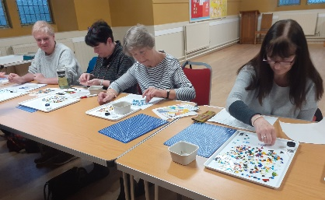
Then we have our next lot of taster sessions in partnership with The Cultural Spring. We hope we can hold two sessions before Brownies on a Friday, to encourage them to get involved too. One of these sessions will be drumming, split into two:
4.30-5.30pm for young people and then 6.00-7.00pm in the upper hall for older people. The second week will be something to do with phone cameras and photography, the detail is under discussion. The other two taster sessions will be on a Tuesday again, but probably later in the afternoon to help with parking. These will be linked to working with pewter, maybe to make a clock, or embossing, or even making jewellery, again the detail is still being discussed.



Please let me know what you think of these possibilities, and hopefully support them when the workshops are finalised and held during spring.
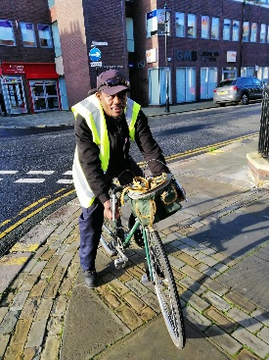

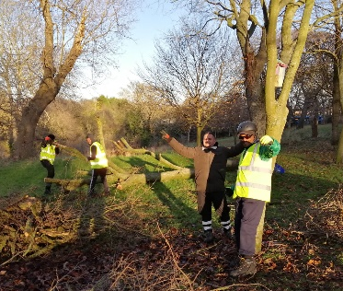
Recently Dave and I spent a couple of hours helping the East Rangers/ ICOS with maintenance work in Backhouse Park. Dave was lopping off shoots from the base of trees and I was litter picking until the snow and the cold beat us! Whilst working with them Daniel showed me some photos of the bikes we have donated being used and told me how grateful the recipients were. Please look again in your sheds and offices and remember that ICOS are always on the lookout for bikes and computers for those they help!

Hopefully we will develop the conversational English sessions they are hoping we can deliver together, in partnership, early in the new year. The larger the team of volunteers we can recruit the less of a commitment we will need. My aim is to recruit 6-8 volunteers so the commitment will be a couple of hours each month. Please let me know if you are interested.

Thank you too for the amazing collection of Christmas gifts you pulled together for those families which Love Amelia support in a very short period of time. Maybe we can become a regular collection point for them in the future!

So hoping you have had the Christmas you have wished for, that you were able to spend time with you family and friends, but also knowing that we, as a church fellowship, when we come together are also helping those less fortunate than ourselves to celebrate this special time of year. With every blessing,

Alison Dalton, your
Church Related Community Worker
07908110121
crcw.alison.dalton@gmail.com
Lectionary Readings
January 2023
1 - 7 January - Opening doors
New Year: Ecclesiastes 3.1-13; Psalm 8; Revelation 21.1-6a; Matthew 25.31-46

8 - 14 January - Let’s do this
Baptism of the Lord: Isaiah 42.1-9; Psalm 29; Acts 10.34-43; Matthew 3.13-17

15 - 21 January - Come, see, tell, repeat
Epiphany 2: Isaiah 49.1-7; Psalm 40.1-11; 1 Corinthians 1.1-9; John 1.29-42

22 - 28 January - About turn
Epiphany 3: Isaiah 9.1-4; Psalm 27.1,4-9; 1 Corinthians 1.10-18; Matthew 4.12-23

Church Services January 2023

(All services at 10.45am in the Sanctuary unless otherwise stated)

Jan 1st Christine Hutchinson and Barbara Mitchell.
Jan 8th Elisabeth Meikle. Short Church Meeting afterwards.
Jan 15th Joint Pastorate service at Roker URC with short Church Meeting afterwards. 11 am.
Jan 22nd Barbara Ledger
Jan 29th Revd Jane Rowell followed by Bring and Share lunch so that we can get to know Jane. Details to follow.
The Church Meeting after the service on Sunday 8th is in connection with the sale of Queen Alexandra Road Manse in order to purchase a more suitable manse for Jane Rowell. The meeting at Roker on Jan 15th is to agree the Terms of Settlement for Jane. It is hoped that neither meeting will take very long.
January 29th is the first service led by our new minister and a lunch is being arranged after the service so we can start to get to know Jane better. More details when arrangements are fixed.

Scheduled Meeting dates 2023

Elders Church Meeting
Tues 21st Feb Tues 21st March
Tues 16th May Tues 20th June
Tues 15th Aug Tues 19th Sept
Tues 7th Nov Tues 28th Nov
Please note change of meeting time agreed at Church Meeting, meetings will now be held from 3 to 5pm.



While many are enjoying a festive time of celebration through the winter, for some living alone this time of year can emphasise loneliness or add increased financial pressure. As darker nights draw in, we can feel less inclined to go out, but staying in can leave us feeling isolated. With more than 4 million people in the UK living alone, many will be facing this challenge or worrying about living costs this winter.

#WinterHomeshare
Homeshare UK are a trusted national charity seeking to reduce social isolation by matching local people who are currently living alone with someone looking for affordable housing in their area to build companionship with mutual benefit, and we are thrilled to have launched the scheme in the North East. We’d love you to share this idea to help us raise awareness of our #WinterHomeshare drive this year.

For the householder opening their home to someone looking to share they benefit from:

- Someone to share their home and memories with
- Someone who can help with light duties around the house such as shopping, gardening
- Someone else around to help us feel safer during the darker nights
- A robust matching process to offer reassurance you are opening your home to someone who has undergone stringent checks and suits your lifestyle

For the home sharer moving into the home they benefit from:

- An affordable housing solution keeping down costs during the cost-of-living crisis
- A safe and happy home with someone to share their life with
- Gaining experience through offering support to the householder
- A robust matching process to know they are entering a safe home that suits their needs

Please share the attached flyer with anyone you think could benefit and invite them to contact me via 07585 536 138 or emily@sharedlivesplus.org.uk or visit https://homeshareuk.org/homeshare-in-merseyside-and-the-north-east/to find out more.

Please send copy for February Newsletter by 22 January to rosina.anderson1503@ntlworld.com

