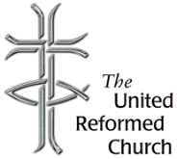
Stockton Road Church News
September 2021

5 Warnham Avenue, Grangetown,
Sunderland SR2 9PH
Tel 0191 549 9595

AFGHANISTAN
Dear All,

I recently wrote a reflection for the Synod e-News Letter about Afghanistan and the future of the country’s refugees.

Since I have written the reflection there have been changes. The Taliban have now fully taken control of the country and are about to announce a new government. Mark Sedwill, who is a previous ambassador to Afghanistan, and an advisor to British prime ministers, has declared that the emergency airlift out of Kabul has only helped a “relatively small number”. He reckons that greater pressures were likely to emerge as people flee overland (Guardian, 2nd September 2021).

In the reflection I referred to two blogs about Afghanistan that were released by the Joint Public Issues Team (JPIT). JPIT links the work of the Baptists, Church of Scotland, Methodists and URC in issues of justice and peace.

One of the blogs by Steve Hucklesby reviews the twenty year military campaign in Afghanistan and considers what the future may hold (A﻿fghanistan – what will the future hold? | Joint Public Issues Team). The other blog is by Hannah Brown who is concerned about how this county might receive refugees (Why the UK is setting itself up to struggle in response to conflict in Afghanistan | Joint Public Issues Team).

I found that both blogs made interesting reading and cast much light on Afghanistan. It was Hannah Brown’s blog that reminded me that there is campaigning that we need to do, in order to ensure that Afghan refugees don’t find themselves arriving into a hostile environment.

One of the concerns is the supporting the education of women in Afghanistan. The question is whether sufficient aid will be provided, it is only recently that the government aid budget has been cut to 0.5% GDP, this surely provides constraints over what this country can do to help the people of Afghanistan in the coming weeks and months. It raises for me the question of whether we should write to our MPs again to raise budget in order to help not only Afghanistan, but other places which are struggling having sufficient Covid-19 vaccine, and victims of natural disasters.

The support needed for Afghan refugees comes at a time when the Government’s Nationality and Borders Bill is working its way through parliament. The measures included in the bill fail to protect those in need of safety and at the same time treats them as criminals. While it is positive that the Government has given a number of the Afghanistan refugees leave to arrive into this country, there will still be many more who are caught up in the conflict who will be forced to flee by dangerous and unorthodox routes and will become victims of the new bill should it come into force.

What we can do is write to our MPs, call upon them and Peers to challenge and amend these changes in policy. We can pray for Afghanistan and its people. We can sign petitions and send letters.

Prayer for Afghanistan

O God,
We pray for Afghanistan and its people,
We pray for those who stay,
May they build a government of peace.
We pray for those who leave,
May they come to a place of welcome.
We pray that the Governments of the world
Will act in wisdom.
We pray for ourselves,
In the decisions we have to make.
Help us find the appropriate action,
In the face of this crisis.
We offer our prayers in the name of Christ.
Amen

David Whiting

Lectionary Readings September

5 - 11 September - No borders
Proper 18: Isaiah 35.4-7a; Psalm 146; James 2.1-10 (11-13) 14-17; Mark 7.24-37
12 - 18 September - Package deal
Proper 19: Isaiah 50.4-9a; Psalm 116.1-9; James 3.1-12; Mark 8.27-38
19 - 25 September 2021 Jostling for position
Proper 20: Jeremiah 11.18-20; Psalm 54; James 3.13-4.3,7-8a; Mark 9.30-37
26 September – 2 October 2021 Living your best life?
Proper 21: Numbers 11.4-6,10-16,24-29; Psalm 19.7-14; James 5.13-20; Mark 9.38-50

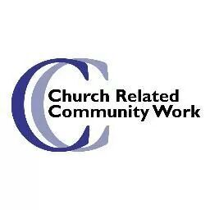

Thinking Allowed!
Well, I don’t know about you, but for me, it feels a long time since I last wrote one of these articles. Of course, it isn’t that long, only a few weeks really. However, those weeks have seemed productive, take a look below and decide for yourself.
In the past, in this role, with other projects, I have found things have tended to slow down over the summer, less meetings, emails etc., but sometimes with more family friendly community events. This has meant historically that I have used this time to catch up before things become hectic again in the Autumn.
Perhaps that sense of productivity comes from the churches, including Messy Church, physically coming together again, as we have done during Church and Elders meetings too. I wonder if this meant I have a deeper sense of belonging and acceptance from you? If so, thank you very much!
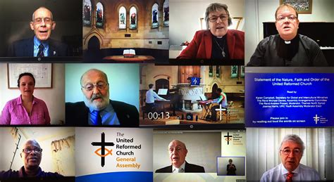
Perhaps you would like to know some of what I have done on your behalf during July and August? I have:
- Attended General Assembly, which was thought provoking, exhausting, being online, but as always both refreshing and inspiring.
- All of our granddaughters, daughters and their partners have come to stay at the ‘Dalton hotel’ at the start of the summer holidays, again exhausting but very lovely too.
- Supported those at Boldon United Reformed Church as they have made their sad decision to close.
- I have managed to catch up on the backlog of emails sitting in my inbox going back to April, there are still ones there from last summer as we were too busy moving here. I will check them one day, but not yet!
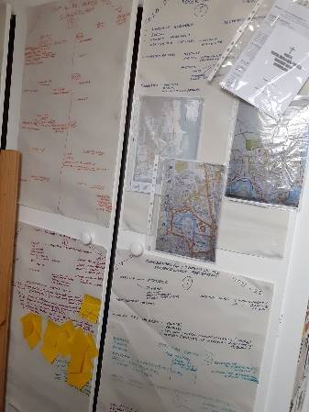
- I have spent some time with sheets of newsprint and pens reflecting on all that has happened this year and the future possibilities that are beginning to come in focus as I begin to write a report of this first year of ministry in Sunderland.
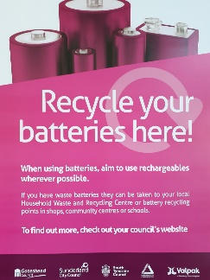
- I have coordinated and received the battery recycling tube at Stockton Rd United Reformed Church (see separate article below). Of course, this was an Elders decision, as I was able to share an invitation which has come through the networks I am building on behalf of the partnership. I realised this could link with your hopes and dreams for the future having read a Mission Manifesto which was shared with me recently. This said - Stockton Rd United Reformed Church recognise God’s gift of creation and our role in looking after it, promoting care and concern for our local and wider environment. We aim to look at the issue of recycling within the church.’
- I am in the process of inviting a representative of the Moneywise Credit Union, on behalf of the Elders, to join us on the 5th of October at 7.00pm. Our hope is that this conversation will enable us to understand how we can support them as they try expanding their work in Sunderland offering a counter to doorstep lending and exploitation which is increasing after this year of the pandemic. If you would like to know more, please join us then.
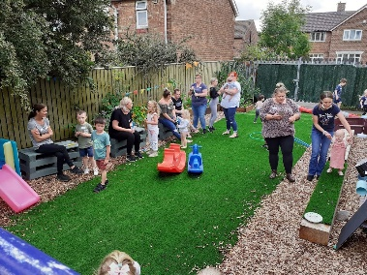
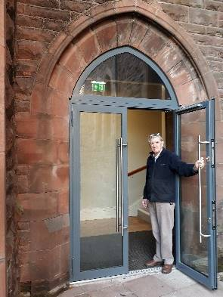
- Hopefully in the Autumn there will be a second meeting when we will begin to explore what you, the church, would like to happen in the church grounds, especially now we have such a beautiful door to welcome people. Perhaps we need to make the grounds more welcoming, and community focussed too? Come along on
the 9th of November at 7.00pm so we can begin to explore our thinking together. All of this builds on the networking I have done during this initial year as your Church Related Community Worker.
- Finally, I have been excited by the reopening of Messy Church over at the Grindon Church Mission Project. It was great to see some of our church members sharing hospitality with approximately nine families, presumably that meant 9 carers, plus 14 children were counted I believe. Being able to join that worship, I was reminded how much I love Messy Church, what a privilege it was to be welcomed by these families. If you feel able to help in the future, the next one is planned for the 19th of October, please contact Barbara Mitchell, Christine Hutchinson or myself.

A quick reminder before I knuckle down to compiling the annual report of our work for this first year of my ministry with you in Sunderland, I will be on leave after Bank holiday Monday for one week and then at the Church Related Community Work Residential from the 7-10th of September so there will be a delay in answering any emails or phone calls during that period. Therefore, please accept my apologies for attendance at the next church meeting, hopefully I will see you at church on a Sunday or at the meeting with the credit union in October.
A prayer taken from the United Reformed Prayer Handbook 2021, Conversations, for Sunday the 5th of September, page 56, something to reflect on…
Who is at the table?
We sit at a table and share in a feast where even the remnants of what we enjoy are far more than many people even dream to relieve their despair.
We laden our table with ‘treats’ denied to many.
Love, Justice, Acceptance, Wisdom Truth, Security
these are not commodities to be protected from our neighbours, for the feast can only truly begin when all guests take their God-given place.
The answers to ‘When?’ ‘Where?’ ‘Who?’ and ‘How?’ bear no ‘ifs’, ‘ands’ or ‘buts’. If our actions do not speak this, how can we claim the name of the One who cries justice for the undesired and excluded?
Please help me, Lord, to welcome all – not just the impressively cloaked, or those with a pass to my Comfort Zone.
Open my ears to hear the fullness of your message, and let your cry be lived out in me. Amen
David Williams
I’m sure we’ll bump into each other again soon, may God bless you and yours,
Alison Dalton
Church Related Community Worker,
07908110121, crcw.alison.dalton@gmail.com

BREAD FASCINATING FACTS

I was preaching at Stockton Road on 1 August, and the text was 'I am the bread of life'.

As part of the service, I gave 10 fascinating facts about bread that I thought may be interesting for other people to read

- Sliced bread was only invented in 1928 and was referred to as the best thing since bagged bread.
- The distinction of “upper crust” comes from the 1600s. When the bread was made in stone ovens the bottoms would become dirty from ash and soot. If you were wealthy, you cut the bottom crust off and just ate the “upper crust” part of the bread.
- Bread goes stale 6x faster in the fridge than at room temperature.
- Before the Eraser was invented people used soft bread crumbs to erase pencil marks.
- The first meal consumed on
the moon was bread and wine. Buzz Aldrin brought with him communion bread and wine, along with a small silver chalice, and held communion during a requested radio blackout shortly after landing.
- A baker’s dozen wasn’t strictly 13. Bakers gave extra bread to avoid being penalized for selling short weight, so a dozen could be 13, 14 or even 15.
- Bread is one of the only foods that is eaten by people of every race, region and culture.
- Breaking bread is a universal sign of peace.
- Bread appears 360 times in the Bible. It appears 280 times in the Old Testament and 80 times in the New Testament.
- Jesus was born in Bethlehem and this translates as ‘House of Bread’

Barbara Ledger

LONG SERVICE PRESENTATION – 25 July 2021

On 25th July 2021 a presentation was made to Alan Dixon for all that he has done on behalf of St Bede United Reformed Church over many years.

Alan was received into membership of Sorley Street Congregational Church in 1966, he served as secretary of the Fellowship of Young Congregationalists during the 1960s and 70s. He became an elder and deacon in 1969 and was first appointed secretary in 1972. Alan currently is the Sunderland and Boldon URC Partnership Treasurer a role he has held since 2000.

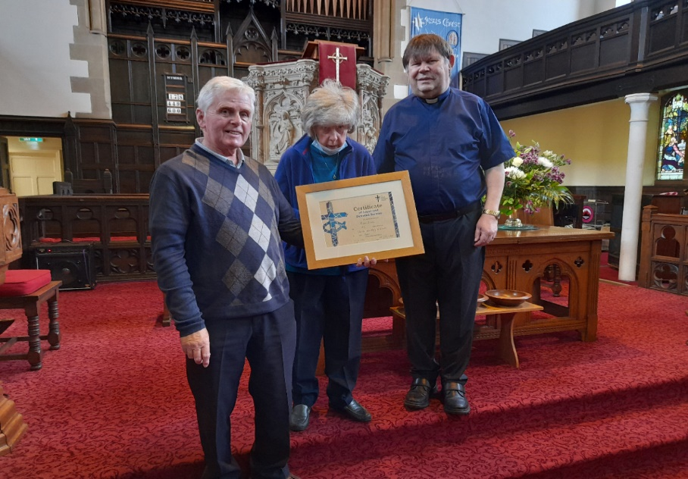

Hello everyone

I thank all involved for attending the service today it was somewhat more than expected. To have family turn up then to have refreshments in the hall was much appreciated.

The glass gifts were absolutely beautiful and an example of what is available at our Glass Centre. I can now claim to own a Lowry. (Paperweight). The wonderful floral presentation was also much appreciated by Margaret.

The sense of organisation and friendship for today is another example of our caring fellowship and future together.

Thank you all again
Alan Dixon

BOLDON URC FINAL SERVICE

On Sunday 1 August a Church Meeting took place at Boldon Church.

It is with regret that I announce the closure of the Church. The final service will take place at 2 pm on Sunday 12th September. During the service we will be marking more than 150 years of worship and witness. After the service there will be a party.

Best wishes

David Whiting

CHURCH SERVICES AT STOCKTON ROAD SUNDAYS 10.45AM

Sept 5th Elisabeth Meikle 10.45 am

Sept 12th Revd Dr David Whiting. 10.45 Communion service

Service to mark the closure of Boldon URC 2 pm. Please let Elisabeth Meikle know if you wish to attend.

Sept 19th To be advised later

Sept 26th Partnership Service at Stockton Road to mark David Whiting’s retirement. 10.45, followed by refreshments.

Why are we being asked to recycle our batteries through Church?
I don’t know about you, but Dave and I have been trying to do our best to recycle all sorts of things for 30 years or more now, in fact you could say Dave’s quite obsessive about it!
I am also aware of battery tubes all over the place. I spotted one in the Sainsbury’s on Sea Rd when I popped in to pick up some bits the other day.
However, I recently received an email from Groundwork Northeast that made me think. In that email I was told that there is an almost weekly issue of fires in refuse carts or centres caused by batteries catching fire. I began to ponder this a little, surely we all recycle batteries nowadays, but then I thought again, I have Dave who ensures we do recycle these things. However, I suddenly thought that if it was down to me, I would probably forget the small circular batteries, they are so small and hidden in things, I think I would forget them!
Here at Stockton Rd URC, we have lots of groups using our building so, a bit like the supermarkets, we are an ideal place for people to drop their old batteries off when they are dropping off the children for dance classes or brownies etc., or for us to drop them off when we come to church? After all I have recently read in the Church Mission Manifesto that we want to find more ways to care for God’s Creation through recycling things.
However, Raine, as our Health and Safety Officer asked rightly that if batteries are causing all those fires, are they a fire risk in our building?

When I emailed this question Dawn, my contact, answered, ‘The fire hazard is when the batteries are put into household waste and mixed with flammable materials, then onto a bin lorry the heat created can 'spark' and cause fires’. She is hoping to write us a short piece for our next newsletter, holidays have got in the way of this one, to help us understand a little more.
For now, please support us by remembering to recycle your batteries, no matter how small and hidden by bringing them to church and dropping them in the tube which will be probably sited by the garden door very soon! Thank you, Alison,

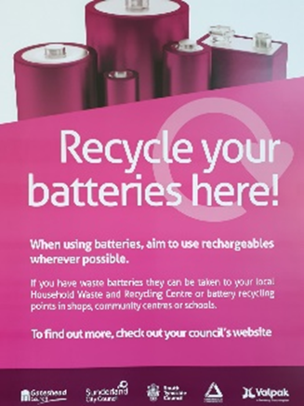

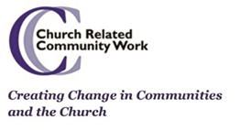

What is a Credit Union? Should we help?

I have a colleague currently working in Sheffield, one of the longest serving Church Related Community Workers, who has been involved with Credit Unions in various locations across the country.

As you will have seen from my piece in this newsletter there is a suggestion that we may wish to support Moneywise Credit Union as it endeavours to help those struggling with financial issues here in Sunderland. Annie Murphy will join us to explore this possibility together on the 5th of October at 7.00pm, at Stockton Rd United Reformed Church. I asked Annie to give us a short introduction to help us understand why we could or should get involved with this. Please see her thoughts below.

Thanks
Alison (Church Related Community Worker)

How do people on limited incomes cope when they have to meet large costs such as?

- Christmas
- moving home
- washing machine replacement
- school uniforms
- a new cooker
- IT equipment
- car repairs
- large fuel bills

Leader of Sunderland City Council, Councillor Graeme Miller said: "One of the most important parts of tackling financial exclusion and tackling poverty is creating better credit and debt solutions.

"Most people at some point in their lives need access to credit and the council wants to see affordable options because nobody should be having to resort to illegal lending and extortionate interest rates.
"Credit unions are for everyone, not just the poor, and a good credit union with a mixed economy of customers can be very useful for those who cannot get access to ordinary bank products”
Since March 2020 Moneywise Credit Union have been working in partnership with Sunderland City Council to bring Credit Union facilities to Sunderland residents.

During the Pandemic many families have experienced financial hardship for the first time due to ill health, being furloughed or losing their jobs.

Sadly, at the same time, Loan Sharks (Illegal Money Lenders) have stepped up their activities to prey on the most financially vulnerable as people are unaware of ethical sources of credit. Loan Sharks are increasingly using social media to draw people into high interest, illegal lending.

Moneywise Credit Union works closely with Local Authorities, Voluntary and Community organisations, local schools, and colleges to help people become better at budgeting, managing their money and accessing ethical loans.

We develop Collection Points in local communities so that people can start saving on a weekly basis. These Collection Points are run by local volunteers.

Find out more about Moneywise Credit Union, what we offer to local communities and residents, and how you could help spread our Services by coming along on the 5th of October, thank you!

A memorial service will be held for
John Shipley
(25 March 1934 – 24 September 2020)

at Sunderland Minster, High Street West, Sunderland, SR1 3ET
on Saturday 2 October at 11am
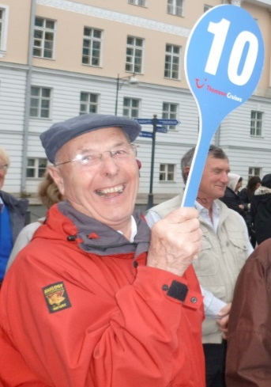
All are welcome to attend the service and a buffet lunch at the church afterwards, but if you hope to do so it would be helpful for seating and catering purposes if you would notify Liz Tinker tel. 0191 567 2632 or 07981194130 etinker16@gmail.com
Collection plates will be available for donations to be divided between the Alzheimer’s Society, Christian Aid and the Minster.
It would be great if anyone would like to submit reminiscences of John for possible inclusion in the service or in a booklet. Please send contributions to Liz.
The service will also be available to view on the Minster’s YouTube channel
(Please be aware that you may still be asked to wear a mask where possible)

Copy for October Newsletter by 19 September to
The induction will be filmed on: 26th of September 2020
At: Roker United Reformed Church,
Sunderland SR6 9JP
This will be released on You Tube for any who choose to join us,
to worship with us, as we celebrate our ongoing journeys together and apart, by the 7th of October 2020
https://www.youtube.com/channel/UCFgX-JjMdJk8UqMWCZCDfXg
Editor: Anne Anderson (rosina.anderson1503@ntlworld.com)

