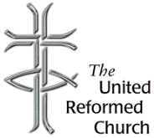
Stockton Road Church News
May 2021

5 Warnham Avenue, Grangetown,
Sunderland SR2 9PH
Tel 0191 549 9595

EMERGING FROM LOCKDOWN

Dear All,

During the month of May, a number of changes will be taking place within the partnership.

For the past months the pandemic has meant that all the churches have been closed for worship. Some who have internet connection have been joining a weekly Zoom service on a Sunday, those without a connection have been receiving a hard copy of the service. Both these means of worshipping will be continuing for a while.

In May, the churches will be beginning to open for worship in the buildings. Roker United Reformed Church will be opening on Sunday 9th May at 11am. Stockton Road United Reformed Church will be opening on Pentecost Sunday, 23rd May at 10.45 am. Boldon United Reformed Church will be opening on the same Sunday at 9.30 am.

For some these changes will mean an exciting move forward. Some have found this period of isolation very difficult, a lonely time, and the opening of the churches will provide an opportunity for meeting friends in person. For the time being at least we will have to continue wearing face masks, and we will not be able to drink tea or coffee after

worship. Hopefully, the time will come when we can drop the masks and share in refreshments after worship, but not yet.

Increasingly people are being vaccinated. The vaccinations are part of a sign of hope, but at the same time there is a paradox. Those of us who were regarded as the most at risk have received our vaccines, whereas others, who were regarded as safest out and about earlier in this pandemic, particularly younger people, may not have received their vaccination, another reason for carefulness and caution.

Others may still be fearful about returning to worship in the church building, others still may find it difficult to attend worship in the building because of various health problems, and that is why the Zoom service will continue at least for a while.

On two Sundays at this time the lectionary presents us with two readings from the Gospel of John, chapter 15. These are passages about the vine and the branches (Easter 5, John 15:1-8, Easter 6, John 15:9-17). Jesus declares “I am the true vine, and my Father is the vinegrower” (John 15:1), he goes on to say, “I am the vine, you are branches” (John 15:5) we are to abide in Jesus as he abides in us, Jesus loves us, and we are to abide in his love.

The image of the vine and branches have been used as a description of the church. Whether we are worshipping on Zoom, virtually, or whether we are worshipping in church buildings, we seek to live up to the challenge of abiding in the love of Christ as Christ abides in us. We are to support each other in love, and we are to do what we can for others in love.

The most recent guidance from the Synod Moderators reminds us that we are to remember the poor and

dispossessed. They suggest we ‘think-give-love’. Referring
to the vaccination process they write that it has been ‘a marvel far greater than any of us may have dared to dream of a year ago’. They also remind us that large parts of the world have struggled, receiving insufficient quantities of vaccine. At the time of writing there has been a particular concern for India.

There are at least two charities that we may consider supporting. In this newsletter in past months there has been reference to the URC supported Christian Aid campaign – ‘Give thanks for your vaccine’ (Give thanks for your vaccine through URC fundraiser). The campaign is supported by URC’s Commitment for Life and the URC is looking to raise £10,000. Another campaign is a UNICEF appeal working with the Covax Programme (Covid-19 vaccines: Help deliver history | Unicef UK). Through its campaign UNICEF wants to help to deliver 2 billion covid-19 vaccinations for health-workers and those at the highest risk on our planet.

Prayer

O God,
Christ is the vine,
And we are the branches,
Christ loves us,
And we abide in his love.

As we begin to emerge from lockdown,
As our churches begin to reopen for worship,
And for others who find a place in our buildings,
We pray that we may support each other,
Both those returning to the buildings,
And those who will continue to worship virtually.
We pray that we may reach out in love,
To the poor and dispossessed.

We pray in the name of Christ,
Who is the true vine.
Amen.

Best wishes

David

Lectionary Readings May

2 - 8 May -Stay connected
Easter 5: Acts 8.26-40; Psalm 22.25-31; 1 John 4.7-21; John 15.1-8
9 - 15 May - Friends
Easter 6: Acts 10.44-48; Psalm 98; 1 John 5.1-6; John 15.9-17
16 - 22 May - The potential of prayer
Easter 7: Acts 1.15-17,21-26; Psalm 1; 1 John 5.9-13; John 17.6-19
23 - 29 May - Filled to overflowing
Pentecost: Acts 2.1-21; Ezekiel 37.1-14; Psalm 104.24-34,35b; Romans 8.22-27; John 15.26-27; 16.4b-15
30 May – 5 June - Getting to know God
Trinity Sunday: Isaiah 6.1-8; Psalm 29; Romans 8.12-17; John 3.1-17

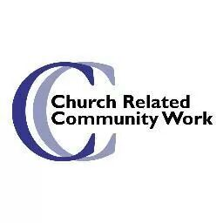
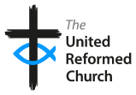

Thinking Allowed!
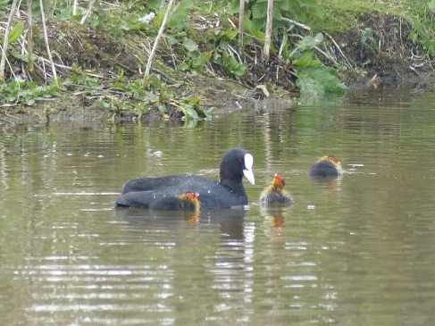
Well, I don’t know about you, but for me the hope that our faith gives us every Easter is currently being reinforced by the beauty of God’s creation. Dave and I, sometimes together, sometimes apart, continue to explore and enjoy the local environment here in Roker during our daily times of exercise. Last Sunday we found the academy ponds, which was lovely, but even more wonderful for Dave was the baby coots we watched swimming on one of them.
The lodge, and moorhens in Tonge Moor, Bolton 2020
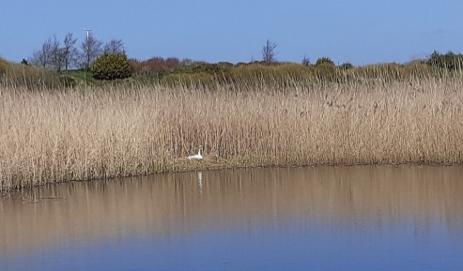
Last year during the first lockdown one of the things that gave us hope throughout that difficult spring was walking in the woodland, or by the rivers, lodges or reservoir close to us. Just a 10-minute walk away from us was a private lodge, to which the owner kindly allowed free access for everyone. Dave would walk almost daily to watch a family of moorhens swim and play, until we moved here. He loves that there is now somewhere
to watch a new, a different family swim and play, and that there may even be baby swans or ducks in time as both were swimming or sitting on a nest.

However, watching nature reminds us that loss happens to everything, and everyone, creation is beautiful, but everything has its season. That family of moorhens started out with seven little ones, but we watched the number decrease as we visited them daily, or in my case weekly. When we left Bolton there were three healthy looking teenage birds which we hope survived to full maturity.
This thought process reminds me of the well-known reading from Ecclesiastes:

3 For everything there is a season, and a time for every matter under heaven:
² a time to be born, and a time to die;
a time to plant, and a time to pluck up what is planted;
³ a time to kill, and a time to heal; a time to break down, and a time to build up;
⁴ a time to weep, and a time to laugh; a time to mourn, and a time to dance;
⁵ a time to throw away stones, and a time to gather stones together;
a time to embrace, and a time to refrain from embracing;
⁶ a time to seek, and a time to lose; a time to keep, and a time to throw away;
⁷ a time to tear, and a time to sew; a time to keep silence, and a time to speak;
⁸ a time to love, and a time to hate; a time for war, and a time for peace.

Dave, my husband, is a very thoughtful and spiritual person even though he is not a Christian. Throughout the last 18 months, or even longer, we have had many conversations
about loss. In the current times the loss of those we love is at the forefront of our minds, but Dave has a wider breadth of thinking on this topic and its links to suffering, which maybe I’ll explore here sometime in the future.
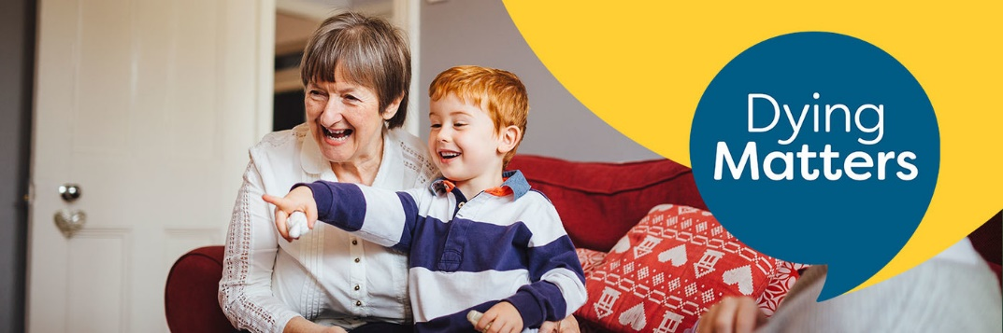
For now, in this week’s Synod newsletter there was a link which feels relevant to today’s thought process here.
In a good place
Dying Matters
Awareness Week
10-16 May 2021
Apparently, annually, a week is put aside to help us think, and more importantly, talk about death, our own death and the death of others. Many people find this is hard. However, because of the recent death of Prince Philip we heard how beneficial this can be for those left behind. Prince Philip had had this conversation, which meant his family were noticeably clear on his wishes and so, hopefully, able to grieve rather than worry if they were doing the right thing by him. This year the Dying Matters movement asks questions of us in their press release:

‘Where people die is changing. More and more people have been dying at home in recent years. And the pandemic has seen this number leap by tens of thousands. We have very little evidence about the quality of these deaths, and whether the right care and support was in place. The quality of care for some people at the end of their life is still not good enough. There is no right or wrong place to die; it will be different for everyone. But it is important for families to think about it, to talk about it and to plan for it. We want people of all ages to be in a good place when they die – physically, emotionally and with the right care in place. Getting there means having some important conversations and taking some careful decisions. Make sure that you and your loved ones are in a good place to die ‘

For a few years now there have been events held across the country, the world, often in or through churches, to help us think and talk about these difficult topics. Grave Talk is something developed by the Anglican church. Is this something that we as churches should or could host, especially as we begin to open our doors again? If this feels something you wish our Elders to consider, for us to explore this further, please email or ring me.

Finally, a prayer which Rachel Poolman, warden of the St Cuthbert’s Centre, Holy Island (Lindisfarne) posted on Facebook yesterday:
After Ecclesiastes chapter 3
In the seasons of the soul there is a time for everything and the persistent presence of hope
A time to breathe deeply and a time to exhale quietly
A time to embrace words and a time to hug silence
A time to see wide eyed horizons and a time to peer to the ground
A time to stride out and a time to walk gently
A time to reach out and a time to withdraw
A time for raging and a time for peace
For everything there is a time and a season and the redeeming presence of the risen Christ © Rachel Poolman

I hope and pray that you stay safe in these unusual times, best wishes Alison.
Church Related Community Worker,
07908110121, crcw.alison.dalton@gmail.com

Copy for June Newsletter by 23 May please to
The induction will be filmed on: 26th of September 2020
At: Roker United Reformed Church,
Sunderland SR6 9JP
This will be released on You Tube for any who choose to join us,
to worship with us, as we celebrate our ongoing journeys together and apart, by the 7th of October 2020
https://www.youtube.com/channel/UCFgX-JjMdJk8UqMWCZCDfXg
Editor: Anne Anderson (rosina.anderson1503@ntlworld.com)

