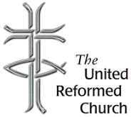
Stockton Road Church News
September 2020

5 Warnham Avenue, Grangetown,
Sunderland SR2 9PH
Tel 0191 549 9595

RETURN TO LIVE WORSHIP

Dear All,

Since about the 22nd March the Churches in the Partnership, like all churches throughout the country, have been closed and so no services have been taking place in the buildings.

In the meantime, I have been sending out copies of the Sunday service either by e-mail or using the post. I have also been running ‘Zoom’ services on a Sunday morning.

We are beginning to move into a new phase. Roker United Reformed Church has been open for worship since 9th August. The chairs are spread out throughout the sanctuary and they are labelled so that people may sit in the same chair each week. This means that not as much time needs to be spent on cleaning the chairs between services. At the time of writing we are still required to wear face masks in church.

Boldon United Reformed Church will be opening for worship on Sunday 6th September and the hall will be used for worship.

The building work is completed at Stockton Road Church and the elders are going to visit the building to work out what

is required in order that Church may be once more open for worship.

Through the past weeks we have been learning new ways of being church, and we have been finding new ways of worshipping. As I indicated above, I have been using Zoom services while other churches have been livestreaming in other ways using ‘YouTube’ or ‘Facebook’.

The United Reformed Church have produced several booklets on the subject. They can all be downloaded from the URC Website. One of the booklets is a general ‘how to’ booklet entitled ‘Using Facebook, YouTube and Zoom to record acts of worship’ another booklet is ‘Livestreaming your church service, some options’. During the lock-down there have been all sorts of booklets produced concerning use of social media, but the third booklet I want to particularly refer to is ‘Doing online differently: A roadmap for digital discipleship’. The booklet explores what we have learned about fellowship, inclusion and connection and conversation during lockdown, and considers how churches may continue to have an online platform beyond the lockdown.

As we open again for worship, live streaming is one of the options we may want to explore. In a recent article in the magazine Reform Lawrence Moore comments:

‘It is time to look to life beyond lockdown and begin to think strategically about what the Church that emerges out of this ‘new normal’ will look like. How will the lessons that we’ve learned during this period usefully shape Church as we move back into our buildings (whenever that will be)? That needs to happen, but whatever we do, we need to ensure that we don’t simply go back to church life before the pandemic’ (Reform, July/August 2020, p.24).

This is encouragement for us to explore what we need to do in the future as we reopen our buildings for worship, but equally we must not ignore the weaknesses of being an online church. We must not forget that there are many who can never get online. We may want to livestream service, and we may want to do this but equally we remember that people cannot walk into an online church, whereas they can walk into a church that is open for worship and their needs can be identified and met.

Best wishes

David Whiting

Lectionary Readings September
6 - 12 September - Held together
Ezekiel 33.7-11; Psalm 119.33-40; Romans 13.8-14; Matthew 18.15-20
13 - 19 September - How many times?
Genesis 50.15-21; Psalm 103(1-7),8-13; Romans 14.1-12; Matthew 18.21-35
20 - 26 September - I don’t know what to choose
Jonah 3.10-4.11; Psalm 145.1-8; Philippians 1.21-30; Matthew 20.1-16
27 September - 3 October - Make my joy complete
Ezekiel 18.1-4,25-32; Psalm 25.1-9; Philippians 2.1-13; Matthew 21.23-32

A Thank-You from the URC

From: Ian Hardie, Treasurer of the United Reformed Church August 2020
and John Piper, Deputy Treasurer

To: The members and friends of all our 1,400 URC congregations

‘THANK YOU’ for your unique and vital contribution to the life of the United Reformed Church, and for the work of the kingdom which we are able to do together in God’s name
We are living through an extraordinary and challenging time – a very anxious time for everyone; a difficult time for many; and a time of suffering and loss for some. Yet, the main purpose of this letter is to say ‘thank you’ to each of you for all that you have done for the Church in the past; for all that you continue to do even in these difficult times; and for what you will do in the future.

As we are treasurers, you will not be surprised that the focus of this letter is on finance. But we recognise that finance is only a means to the end which is our doing of God’s work together.

‘Thank you’ for your giving to your local church. Financially, this giving is the lifeblood of your own church and of the whole United Reformed Church across England, Scotland and Wales. It is this personal giving that enables your local church treasurer to pay your church’s bills. Typically, the largest of those ‘bills’ is the contribution your local church pays to the URC Ministry and Mission Fund. This Fund meets the central costs of the United Reformed Church. The total budget is around £20 million and is approved each year by Mission Council. Over 80% of this money is spent on ministers and church related community

workers – their training, stipends and pensions. But the other 20% also achieves an enormous amount on behalf of us all.

General Assembly 2020 was severely constrained because of the Covid-19 lockdown, but the reports written for General Assembly are available on the URC website, and they paint pictures of all the work that has been done in our name over the last two years and much of that work is ongoing.

‘Thank you’ for your giving and the giving of your local church last year. In 2019, over £19.4 million was given by local churches and synods to the Ministry and Mission Fund. The total contributions from local churches reduced very slightly but the average giving per member has, once again and remarkably, gone up by more than inflation.

‘Thank you’ for your continued giving this year. We fully understand that circumstances this year are difficult. Most local churches have been unable to meet for over five months. We have not had the usual opportunities to make our offerings for the work of the Church. But most of the costs of the local church and of the denomination have not reduced and some have increased as a consequence of the pandemic. We are also aware that some have lost income or work this year and are therefore in great financial difficulty. But there are others on fixed incomes who are actually better off than they might otherwise have been. So, please continue to give what you can in whatever way you can – or save it up until you can hand it over.

Any giving of ours is a response to the amazing generosity and love of God which we see in Jesus. Nevertheless, it is important for us to say ‘thank you’ to each and all of you.

If you have any questions or comments arising from this letter then please speak to your church treasurer, who has been provided with more detailed information. If they are not
able to help directly then they can get in touch with the finance team at Church House.

Yours in Christ, Ian and John

Church Alterations / Re-opening

The Elders and Development Team met last Tuesday in church for the first time since lockdown. It was also the first opportunity we had to look at the alterations and they are amazing! The contractors have done an excellent job and we are sure you will be pleased with the results. There are a few items still to complete and then we will be able to start to sort out all the furniture and "stuff" that has accumulated; it's all in different places in the building and we will have to re-allocate storage for it all, a big job.

We are considering opening for worship in the Lower Hall to begin with, following all guidance from the government and URC regarding cleaning and social distancing. We are trying to work out how many people would feel comfortable enough to return to worship and will be seeking your views. At present we think it unlikely that we could meet before mid-late October.

Every Blessing
The Elders and Development Team

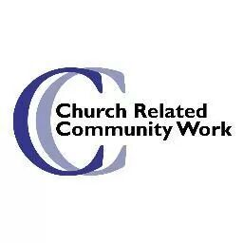

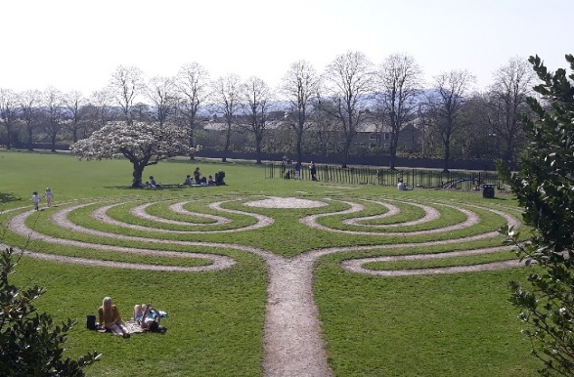

Labyrinth in the grounds of Clitheroe Castle, Lancashire

Thinking Allowed!
The picture above is a picture I took on a visit to a little town in Lancashire, Clitheroe many years ago. Clitheroe is a town dominated by its historic castle which has a public park in its grounds. It was a favourite train ride, around an hour there and another hour back, Dave loves trains! We went on our days off, often with our granddaughters when we were caring for them, they loved the train ride too!
This labyrinth is situated in a public, secular space but anyone was able to walk the labyrinth, to use it as a prayer tool, which I did whenever we visited this lovely town
If you would like to know more about labyrinths, their history and their use as a prayer tool let me know and maybe I’ll be able to focus just on that as a topic in a future piece.

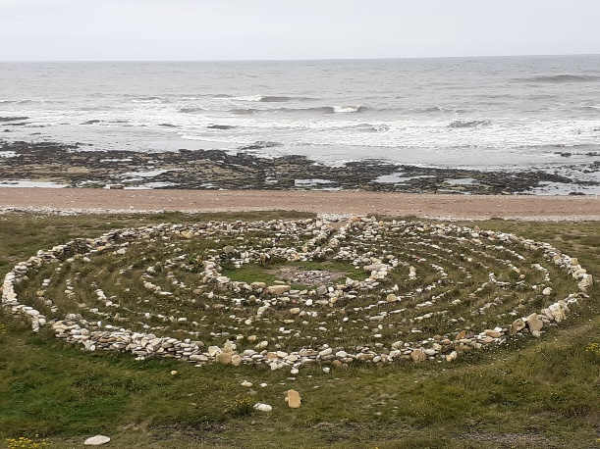
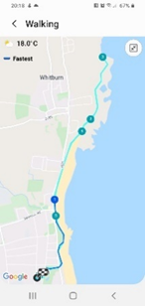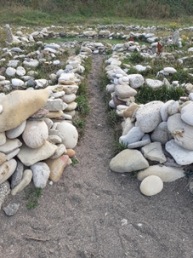

Those of you who have already become a Facebook friend will be aware that I am excited to find there is a labyrinth here too! It is called Finn’s labyrinth and is just above Whitburn bay, I have walked to and spent some time within it for the last three weeks. I plan to visit it weekly as part of my personal prayer life, but would love to know the story, if there is one, of its building. So, if any of you are aware of that story, or perhaps knows someone who does, please feel free to let me know.
Last week as I walked the labyrinth I was mulling over this piece, the deadline was looming and I hadn’t really thought much about what to write, as I looked down I found myself getting grumpy, even though I was praying.

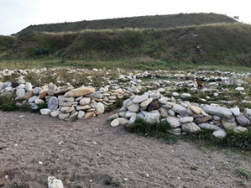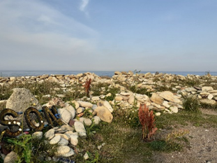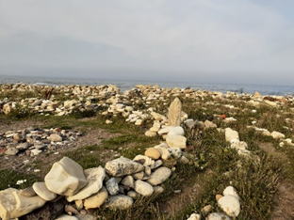

Why was this? Well I found a larger can, a beans tin and some of the labyrinth walls had been knocked over and this bothered me.

For me, this place had already become special, a thin place. I am guessing for the person or people who built this it is very special too, but even for me as a new comer I could see that within a week it had not been treated with respect, or so it seemed to me.

I picked up the cans, where I could I picked up the stones and rebuilt the walls whilst I mulled this over…
Those who did this had no understanding of my feelings, of how I or anyone else felt because to them this was a maze, a place to play and have fun, of course that is what they had done and maybe it had got damaged in the process but it was being used for a good purpose even if it was different to me, what right did I, the newbie, have to moan!

I continued my walk into the centre, sat down, continued to pray and then picked up my phone and searched for a Bible reading on my phone, a Psalm came to mind:

121 ¹⁻² I look up to the mountains;
does my strength come from mountains?
No, my strength comes from God,
who made heaven, and earth, and mountains.
³⁻⁴ He won’t let you stumble,
your Guardian God won’t fall asleep.
Not on your life! Israel’s
Guardian will never doze or sleep.
⁵⁻⁶ God’s your Guardian,
right at your side to protect you—
Shielding you from sunstroke,
sheltering you from moonstroke.
⁷⁻⁸ God guards you from every evil,
he guards your very life.
He guards you when you leave and when you return,
he guards you now, he guards you always.
(The Message)
I wondered what this was telling me…
I reflected that sometimes we, as church people, feel the same as I had about the labyrinth when people from our community come into our buildings, perhaps they use our special buildings, or the things within them in a way that feels wrong to us, maybe because they too have different perceptions, different uses for them than we do?
Maybe this Psalm came to mind to remind me that we do not need things, even things created by God, to guide us, to keep us safe, to make us the people we are meant to be. We need to keep focussed on God, and that means to remember the new clarity Jesus gave us at the Last Supper, retold in John 13:
³⁴ I give you a new commandment, that you love one another. Just as I have loved you, you also should love one another. ³⁵ By this everyone will know that you are my disciples if you have love for one another.’
I guess we, I, was being reminded that Jesus commanded us to love all, not to judge those who treat our special things differently to how we would like, but to remember that God wants us to serve people, to share his love with them. Therefore, our understanding and acceptance is important to help us share that love and inviting them into our buildings is a very concrete way that we can achieve that commandment to share God’s love.
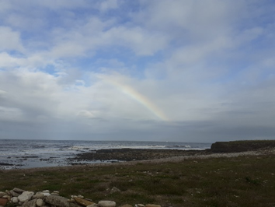
Yesterday as I began the outward walk, away from God and back into community and life, I looked up and, I feel received a very precious gift to remind me of God’s love today, here, and now, what do you think?
I’m afraid I’ve not told you much about the work I have been doing this month on your behalf so far, but maybe it is enough to say that I continue to explore, research and try to understand Sunderland, its communities, people, council, voluntary sector, hopes and dreams and more.
I am also beginning to work on the forthcoming Induction which will be filmed on the 26th of September at Roker URC by Amelia Turner the youth placement that Synod has gifted to them. I hope someone from Stockton Rd United Reformed Church, and the other churches, will be involved in some way, but only one person I’m afraid.
Once we know more we will send out an invitation to you all to share in this very special act of worship by watching it on You Tube, whilst hoping we can celebrate the continuation of your project together in a more usual way sometime in the new year, whenever that is possible.
In the meantime, can I share a blessing with you which will be included in the Induction worship

‘If you are searching for the answer
May you find that it is simple,
The answer is love.
Not words and intellect,
The answer is love.
Not money and possessions,
The answer is love.
Not status and position
The answer is love.
Not expectation and judgement,
May you find that it is simple, just love.
A Celtic Blessing for Love by Iain Tweedale

With gratitude Alison
Church Related Community Worker, 07908110121, crcw.alison.dalton@gmail.com

The Captives’ Hymn and Margaret Dryburgh
Father in captivity,
We would lift our prayers to thee.
Keep us ever in Thy Love,
Grant that daily we may prove
Those who place their trust in Thee
More than conquerors may be.

This is the first verse of the hymn sung by Nicola Roberts at VJ Day 75: The Nation’s Tribute which was broadcast on BBC1 and which has been rightly described as one of the most emotional parts of the programme. Yet I felt disappointment that the hymn was not credited to Margaret Dryburgh who is commemorated in Stockton Road. Nor was there any mention of the circumstances in which it had been written and composed in 1941 at the women’s prison camp in Sumatra where it was sung by the choir Margaret organised for Sunday services. Even the title was incorrect, as it was given in the singular as the ‘captive’s hymn’ when Margaret was expressing all members of the Sumatra group’s feelings.

Margaret Dryburgh deserves to be recognised better today as one of Sunderland’s most notable daughters. She was born here in 1890 when her father was minister of St Stephen’s Presbyterian Church in Monkwearmouth. He moved to the Church in Swalwell the same year, but returned with his family to Sunderland in 1906 following retirement. After gaining a BA and her teacher’s diploma Margaret taught at Ryhope School for six years from 1911.

In 1919 Margaret became a Presbyterian Church of England missionary in Swatow in south-east China where she was a teacher at the girls’ school. The St George’s Women’s
Missionary Association supported the WMA house in Swatow where Margaret lived and felt she was their missionary. Elisabeth Meikle also recalls that when her mother, Joan, was in the Sunday School Margaret wrote to its members about her work. A further link was through her sister being a member of our Church.

When Helen and I were in China in 2009 with a group from the Friends of the Church in China we met the President of the Guangdong Christian Council who came from Swatow (now Shantou). He told us that his mother had gone to the girls’ school there, possibly at the same time as Margaret was a teacher. He also said that Shantou was one of the strongest centres of Christianity in the province thanks to the foundation work of the Presbyterian missionaries.

In 1927 Margaret moved to Singapore where many people, or their parents, had come from Swatow and, as well as being the principal of the girls’ school, was much involved with the work of the church, especially using her musical talents in training choirs, congregations and schools.

After the fall of Singapore, the ship Margaret was escaping on was captured by the Japanese and she was taken to a prison camp for women and children in Sumatra. Here she organised Bible classes and services and kept up morale by forming a ‘vocal orchestra’ for concerts. Sadly, Margaret died in April 1945, only five months before liberation

Margaret Dryburgh died 75 years ago, but her work left a legacy which we should remember. The final verse of her great hymn must still resonate with many people round the world today.

May the day of freedom dawn,
Peace and justice be reborn,
Grant that Nations loving Thee
O’er the world may brothers be,
Cleansed by suffering know rebirth,
See Thy Kingdom come on earth.
Neil Sinclair

Copy for October Newsletter to Anne Anderson by 20 September
Editor: Anne Anderson (rosina.anderson1503@ntlworld.com)

