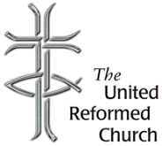
Stockton Road Church News
March 2021

5 Warnham Avenue, Grangetown,
Sunderland SR2 9PH
Tel 0191 549 9595

THY KIN-DOM COME

Dear All,

Last month I wrote a letter about the Lord’s Prayer and Coronavirus. I referred to a book that I ordered as a Lent Study Book entitled ‘Thy Will be Done’ by Stephen Cherry. At the time I was writing the letter the book had not been delivered, however, now I am well into reading the book.

Stephen Cherry, in the introduction to book, says that he wants his readers to immerse themselves in the prayer that Jesus taught his disciples. He draws upon many theologians as inspiration for his study of the Lord’s prayer. Theologians such as Gregory of Nyssa, Thomas Aquinas, Karl Barth, Simone Weil, and Pope Francis. He goes on to express his appreciation in the simplicity and lightness of the Lord’s Prayer, but at the same time we need to de-familiarise ourselves from it so we can fully appreciate the challenges and deeper mysteries that it presents.

The book is divided into six parts, one part for each week of Lent, and each part has six chapters. Part One is entitled ‘Heaven’. In chapter 1, Stephen Cherry outlines the shape of the prayer. It is followed by three chapters to do with the prayer being addressed to the Father, and two chapters about heaven. In this section he writes about the ‘Motherly Father’ and he considers the problem of patriarchy. He quotes the German biblical scholar Joachim Jeremias (1900-1979) ‘the word “Father”, as applied to God, thus encompasses, from earliest times, something of what the word “Mother” signifies among us’ (p.17).

Stephen Cherry picks up again on patriarchy in Part Two of the book, when he considers the nature of God’s Kingdom. We don’t find Jesus giving definitions. When Jesus speaks of the kingdom of God it is often linked with parables, these are the so-called parables of the kingdom. The kingdom is like a sower, it is like a mustard seed, or like yeast, or treasure hidden in a field and so on. In Jesus’ day the kingdom that his contemporaries knew was associated with Herod and his descendants. The kingdom of God is different to any earthly kingdom, when Jesus uses the word ‘kingdom’ he is not speaking about any earthly kingdom.

There are many feminist theologians who have questioned patriarchy in the bible and have considered alternatives to the word ‘kingdom’. One such alternative is ‘kin-dom’ the removal of the ‘g’ from the word gives us a term that doesn’t sound very different. You can find the word used by a few theologians. One such theologian who gave its use some prominence was Ada Maria Isasi-Diaz, writing from the perspective of Hispanic women living in the USA. For her kingdom is a word about a vertical hierarchy, whereas kin-dom represents a horizontal solidarity. Isasi-Diaz’ solidarity is a union of ‘kindred persons’ who have a common interest and there is a mutuality of interest.

So, what has all this got to do the Lord’s Prayer and it’s use during a time of pandemic?

Stephen Cherry writes:

‘One of the more constructive social responses to the early phases of the impact of Covid-19 on our communities was the recognition that key workers include many in low-paid jobs, and, in particular, that the work of caring for others – that is, meeting the basic bodily and practical basic need of the vulnerable – is poorly paid and hugely undervalued in Western societies. People who say the Lord’s Prayer regularly might expect to feel increasingly uncomfortable and those whose work is vital to the wellbeing of others and the functioning of society are under-rewarded for their efforts’ (p.60-61).

Stephen Cherry goes on to comment that those who exercise care for others are demonstrating a form of ‘kin-ship’ to others. It is this that is ‘the ideal and goal of our prayer’ (p.61).

Best wishes

David Whiting

Lectionary Readings March

7 - 13 March - Under construction
Lent 3: Exodus 20.1-17; Psalm 19; 1 Corinthians 1.18-25; John 2.13-22
14 - 20 March - Looking up
Lent 4: Numbers 21.4-9; Psalm 107.1-3,17-22; Ephesians 2.1-10; John 3.14-21
21 - 27 March - All people
Lent 5: Jeremiah 31.31-34; Psalm 51.1-12; Psalm 119.9-16; Hebrews 5.5-10; John 12.20-33
28 March – 3 April - Caught up in celebration
Palm Sunday: Psalm 118.1-2,19-29; Mark 11.1-11

Give thanks for your vaccine through URC fundraiser
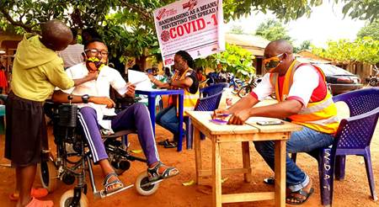The United Reformed Church (URC) is hoping to raise £5,000 for its ‘Give Thanks for Your Vaccine’ fundraising campaign, developed with Christian Aid.
So far, £1,300 has been raised.
In the UK, nearly 18million people have had their first dose of a coronavirus vaccine. But for the poorest and most vulnerable communities across the world, there is little hope of a vaccine rollout. These are people who already face lack of water, food, and basic healthcare.
Christian Aid is already on the ground, helping keep people safe from coronavirus with practical support, but with donations, the charity can do more.
To help the charity, the URC’s fundraising campaign aims to help people show gratitude for their vaccines and help to protect our global neighbours while the vaccine is out of reach.
The Revd Dr Kevin Snyman, URC Commitment for Life Programme Officer, explains: “Although some pharmaceutical companies have promised not to profit from COVID vaccines, the fact remains that many of our Commitment for Life partner regions, already facing the hard edge of climate disruption, must deal not only with a shortage of vaccines, but also the turbulent dangers of debt that will be required to pay for protection against Covid-19.”
Earlier this month, the UK government had been urged to start sharing its vaccine supplies after analysis revealed that out of the 120 million vaccines rolled out to date, 70% of these were administered in the 50 richest countries around the world. It has also been reported that countries like South Africa needed to buy doses of Oxford-AstraZeneca’s Covid-19 vaccine at nearly two-and-a-half times higher than most European countries.
Francis Brienen, URC Deputy General Secretary (Mission) added: "The URC is deeply concerned about the unfair rollout of Covid vaccines around the world. Once again, the poorest and most vulnerable people are being pushed to the back of the queue, with only two percent of the world's population vaccinated so far - the vast majority of them in the richest countries. We must and can do better."
All donations will support Christian Aid's response to the coronavirus pandemic in affected communities around the world, including Commitment for Life's – the URC’s global justice programme – partner regions.
Dr Snyman added: “We must face up to the awful realisation that the URC’s Commitment for Life and Council for World Mission partner regions are being forced to the back of the vaccine line.
“This is simply wrong on so many levels. We know that coronaviruses - like very rich people - do not overly concern themselves with borders. They travel the world without a care in the world. Ignoring the poor is not only immoral, it’s a spectacular own goal. When viruses are left to multiply, their mutations render existing vaccines potentially weakened and ineffectual. Vaccine-selfishness benefits nobody.”
If you or your family member has received a vaccine and would like to express your gratitude by helping the campaign, please make a donation here.
https://urc.org.uk/latest-news/3740-give-thanks-for-your-vaccine-through-urc-fundraiser.html

‘Building for the Future’
A Zoom conference, for all interested parties, to consider strategies for churches and church buildings April 19th 3 – 4.30 p.m.
Some of the questions that many churches have been wrestling with during the pandemic have concerned the implications for the way in which our buildings play a part, for better or for worse, in God’s mission and in local communities and neighbourhoods. The URC Buildings Forum has existed for several years with a focus on these questions and this online conference is intended to be the first of a series that will focus on different aspects of exploring the use of our buildings and capital assets.
The General Secretary, John Bradbury, will give a keynote address to guide our thinking about the purposeful and creative use of our premises; the HeartEdge movement, begun by St Martin-in-the-Fields, will share a little about the ways in which they can support you in the use of your buildings, and there will be at least one story of a creative idea that is being put into practice. It will also be an opportunity for conversation in breakout rooms and importantly will be a listening exercise to hear the questions that you have, the challenges that particular churches face and hopefully something of positive ideas and news. This will assist us in planning further conferences.
This online event is open to everyone, whether or not you’ve been part of the Forum previously. The meeting will be recorded in speaker view so only those providing input will be recorded. To register please email mission@urc.org.uk with ‘Building for the Future’ in the subject line, by April 16th. Along with your name and email address, please tell us which church you belong to or are representing, if appropriate. Login details will be sent a few days before the meeting. Further information and updates are also available on the Forum website homepage www.urcbuildingsforum.co.uk

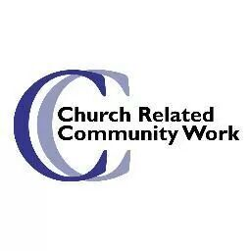
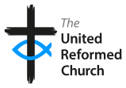

Thinking Allowed!
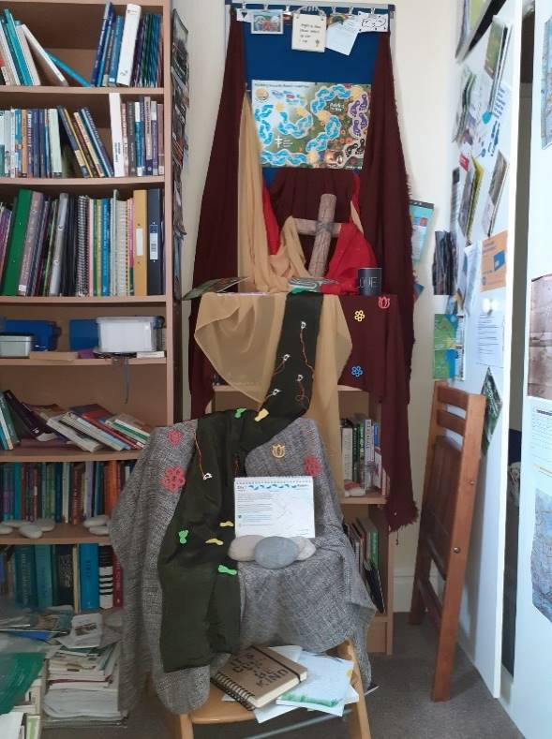
As I write this we have just began Lent. Like others, who I am aware of, I sent for the pack developed by the national United Reformed Church Children’s Ministries team. This pack was building on from the great success of the ‘Hope’ boxes put together at Christmas. Anne kindly put the information about it in the last newsletter where it was flagged as a great resource for all ages. This coincided with my decision this year not to give something up for Lent but rather to take on two new disciplines to aid my personal and professional spiritual development both during Lent and in these exceedingly difficult times. Periodically I put together a visual display which helps me to focus during my own prayer time. This picture is of my current reflective space for Lent. This includes the material mentioned above which was only just received in time for Lent. This pack provides a reflective journal which has helpful points and Bible readings to aid our thinking as we journey through Lent towards the Cross. Using this journal daily is the first discipline I have undertaken for Lent, the second is a commitment to read and reflect on the Gospel of Mark, making, I hope, helpful notes on the way. After all we have all already given up so much in the last year, so giving something up feels less important this year but rather I feel a need for the surety of God’s presence in my life, our lives moving forward, so rereading and reflecting on books of the Bible is a great way to achieve that reassurance.
It already seems a long time ago but early in February the weather was very windy, snowy and wet, so I didn’t attempt my weekly walk to the labyrinth to stop and pray. Instead, even though it was windy and snowy, I walked prayerfully around the cliff park and the promenade. However, this is not always easy as there are often crowds taking their daily exercise in this beautiful place. Luckily, the reason that had brought me here was to my advantage as this meant there were not as many people willing to brave the inclement weather.
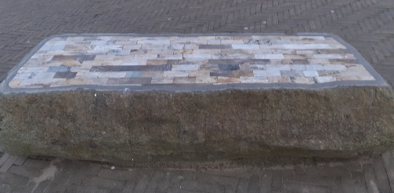
As I walked the stone seats at Seaburn caught my eye, their steadfastness and strength which was needed in the inclement weather. But then I looked again, and it struck me that some of the seats were made of a single stone whilst others were inlaid with a variety of stones which made that seat even more beautiful.
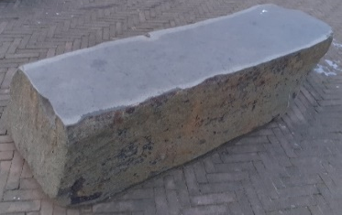
This has led to a long train of thoughts about rocks and patterns. I have taken many pictures and so may revisit the thought processes and reflections these beautiful seats have begun in me in the future. However, for now I will share my first thought. This was about strength and diversity, beauty and belonging, fitting together to be complete. Perhaps these are classic thoughts you have encountered before when people have focussed on jigsaws, perhaps with a missing piece and so not being complete, or ‘liquorice allsorts’ – God has made all sorts for all sorts of people?
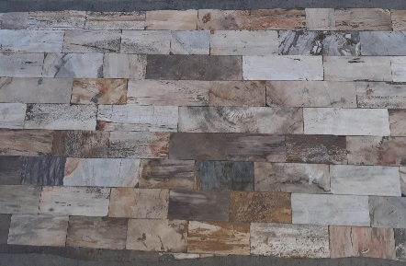
My reflections began with wondering as both seats are strong, both seats are beautiful, but in different ways. However, although both are beautiful, the inlaid seat, for me, celebrates God’s creation much more than the other, which is plainer, even though there is beauty in that simplicity too. This seat does not show us the variety of rocks God has made in creation, as the inlaid seat does. The inlaid seat begins to spotlight, through the rocks being polished and shaped, not only the possibility of many more types of rock but also the individual, different stories each rock has been forged by. Just like us, humanity! There is more vibrancy when we fit together, match each other to show what our God, the God of the whole of creation, has created. Perhaps that will spark further thoughts in your mind? If so, please feel free to ring me, or email me with those thoughts as I would love to hear how God is speaking in you and through you in these dark times…

To finish, a prayer taken from the United Reformed Church prayer handbook 2019, Seasons of the Spirit:

We grow in you O God.
You tend us, nourish us, water us, feed us.
Sometimes we do not bear fruit.
We do not think we are worthy to grow in your garden.
Your mercy is beyond anything we can imagine.
So, we will bless you as long as we live.
We will cling to you; your right hand will uphold us.
For your mercy is beyond anything we can imagine,
and we will grow in you. (Anne Sanderson)

I hope and pray that you stay safe and continue to look to God for solace and care in these difficult times.
Best wishes
Alison.

Church Related Community Worker,
07908110121, crcw.alison.dalton@gmail.com

Copy for April Newsletter by 21 March please to
The induction will be filmed on: 26th of September 2020
At: Roker United Reformed Church,
Sunderland SR6 9JP
This will be released on You Tube for any who choose to join us,
to worship with us, as we celebrate our ongoing journeys together and apart, by the 7th of October 2020
https://www.youtube.com/channel/UCFgX-JjMdJk8UqMWCZCDfXg
Editor: Anne Anderson (rosina.anderson1503@ntlworld.com)

