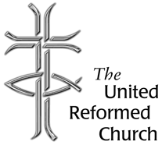
Stockton Road Church News
June 2020

5 Warnham Avenue, Grangetown,
Sunderland SR2 9PH
Tel 0191 549 9595

COVID-19 – WHERE THE CHURCH IS?

Dear All,

Our places of Worship have been closed now since 22nd March, since then we have been getting hard copies of our worship, or else joining in streamed or virtual services. I began by sending copies of the service through post or e-mailing a copy to those who have e-mail addresses, more recently I have been providing links for a service on You Tube or still more recently I have been inviting people to join a Zoom service. If you are interested in joining this service please contact me and let me know, you will need a smart phone, a tablet, or a PC.

At the time of writing it is likely that the Government will be announcing that places of worship can open again for private prayer. The URC has been producing booklets to help churches come out of lockdown, they can all be downloaded from the United Reformed Church web-site (www.URC.org.uk).

The first document was produced by the Moderators, ‘Ready for the new “normal”’. The document is a discussion paper, its purpose is to help churches in preparing a recovery plan. It is divided into three parts. The first part is intended to help people reflect on the journey ahead. The second part picks

up on practical issues concerning resuming activities. The third part considers questions of principle.

In part 1 we are reminded that although we have an uncertain future, still we look forward in hope. There are questions about how we should relate positively to ourselves, to our neighbour and to God during this time of pandemic. Words are provided for reflection:

‘We are on a journey through a pandemic, not knowing our destination, but aware we follow in a line of saints of old, who have set off before us in the footsteps of Jesus, walking the way. Like those before us, we may travel with faith and doubt, hope, and fear, and, perhaps, have a holy encounter along the way. That we travel at all will mean that we are changed. Pilgrimage is about taking and risking such a journey, faith is knowing that we are accompanied by God, hope is in a Kingdom destination, and love may be experienced with companions.

The second part deals with practicalities, and provides questions to consider in the first phase:

- Who makes the decision to re-open?
- Who should come to church?
- Planning the use of space
- Dealing with the trauma

In the second phase there are other matters of concern:

- Physical security check
- Risk assessment
- Check water supply to avoid Legionella bacterium
- Cleaning routines

Phase 3 considers the consequences of social distancing when the buildings open and we get back to worship. There are issues about how we deal with communion, even how we take the offering. The headings for this session are as follows:

- Planning for public worship
- Before and after worship
- Sacraments
- Taking the offering
- All-age interactions
- Activities in the church building
- Re-opening of other congregations in the building
- Resuming external lettings
- Finances

The third part of the document is headed ‘What is the “New Normal” for your Church? This section asks to consider whether we even need a church building, it asks us to think about what worship might look like. It goes on to discuss community engagement, pastoral care, meetings, and management of external users.

The document finishes with a reminder that the world has changed, and it cannot get back to how it was before and ‘in many, many ways it should not seek to do so’.

In the next copy of the newsletter I hope to explore a sister document to the one discussed above. It is entitled ‘New reality, same Mission’.

With every good wish

David Whiting

CHURCH ALTERATIONS

The alterations to the church building are under way and are proceeding satisfactorily so far. The contractors are observing government guidelines with regard to Covid 19 precautions. The project manager visits the site regularly and provides us with a weekly update.

Lectionary Readings June

7 - 13 June - Worship and witness
Trinity Sunday: Genesis 1.1–2.4a; Psalm 8; 2 Corinthians 13.11-13; Matthew 28.16-20

14 - 20 June - Call to action
Proper 6: Exodus 19.2-8a; Psalm 100; Romans 5.1-8; Matthew 9.35-10.8(9-23)

21 - 27 June - When the going gets tough
Proper 7: Jeremiah 20.7-13; Psalm 69.7-10,11-15,16-18; Romans 6.1b-11; Matthew 10.24-39

28 June - 4 July - In the name of........
Proper 8: Jeremiah 28.5-9; Psalm 89.1-4,15-18; Romans 6.12-23; Matthew 10.40-42

Every Tuesday, from March to October, the Iona community organises a pilgrimage around Iona, in which everyone is invited to join. The pilgrimage visits places of historical and religious significance on the island. At each place there is a brief reflection and prayer, sometimes with silence or songs.

IONA: THE ABBEY
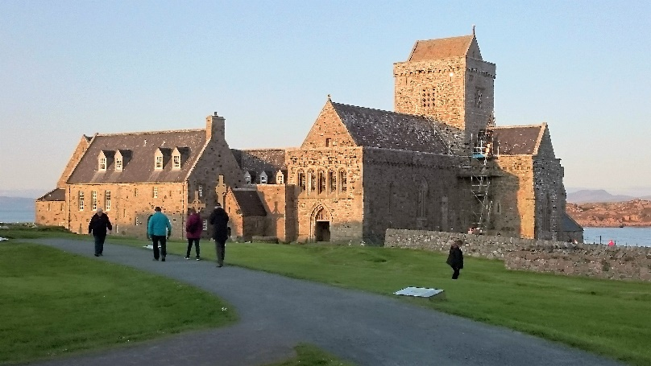
Columba’s monastery survived until the end of the 12th century, despite repeated Viking raids. Around 1200, the sons of Somerled – ‘King of the Isles’ – founded a Benedictine abbey here. Pilgrimage to St Columba’s Shrine continued to thrive, though monastic life on Iona ended with the Protestant Reformation of 1560.
In 1693, the abbey came into the possession of the Argyll family; by the 19th century it was in a dilapidated state. In 1874, the eighth duke started to repair the church, but realised that he would not be able to finish it in his lifetime. In 1899 he donated it to the Iona Cathedral trustees (who are still responsible for its upkeep) under two conditions. Firstly it was to remain as a place of worship, not just a tourist destination and secondly it should be a home for Christians of all denominations. By 1910, restoration was complete, thanks to public subscriptions.
Below is St Columba’s Shrine, the small chapel to the north of the west (main) door. Because of the High Crosses situated nearby it is thought to be a place of great importance, possibly even the original site of St Columba’s grave. Columba’s bones were taken to Kells in Ireland for safety in 849, although some may have been returned to Iona later on.

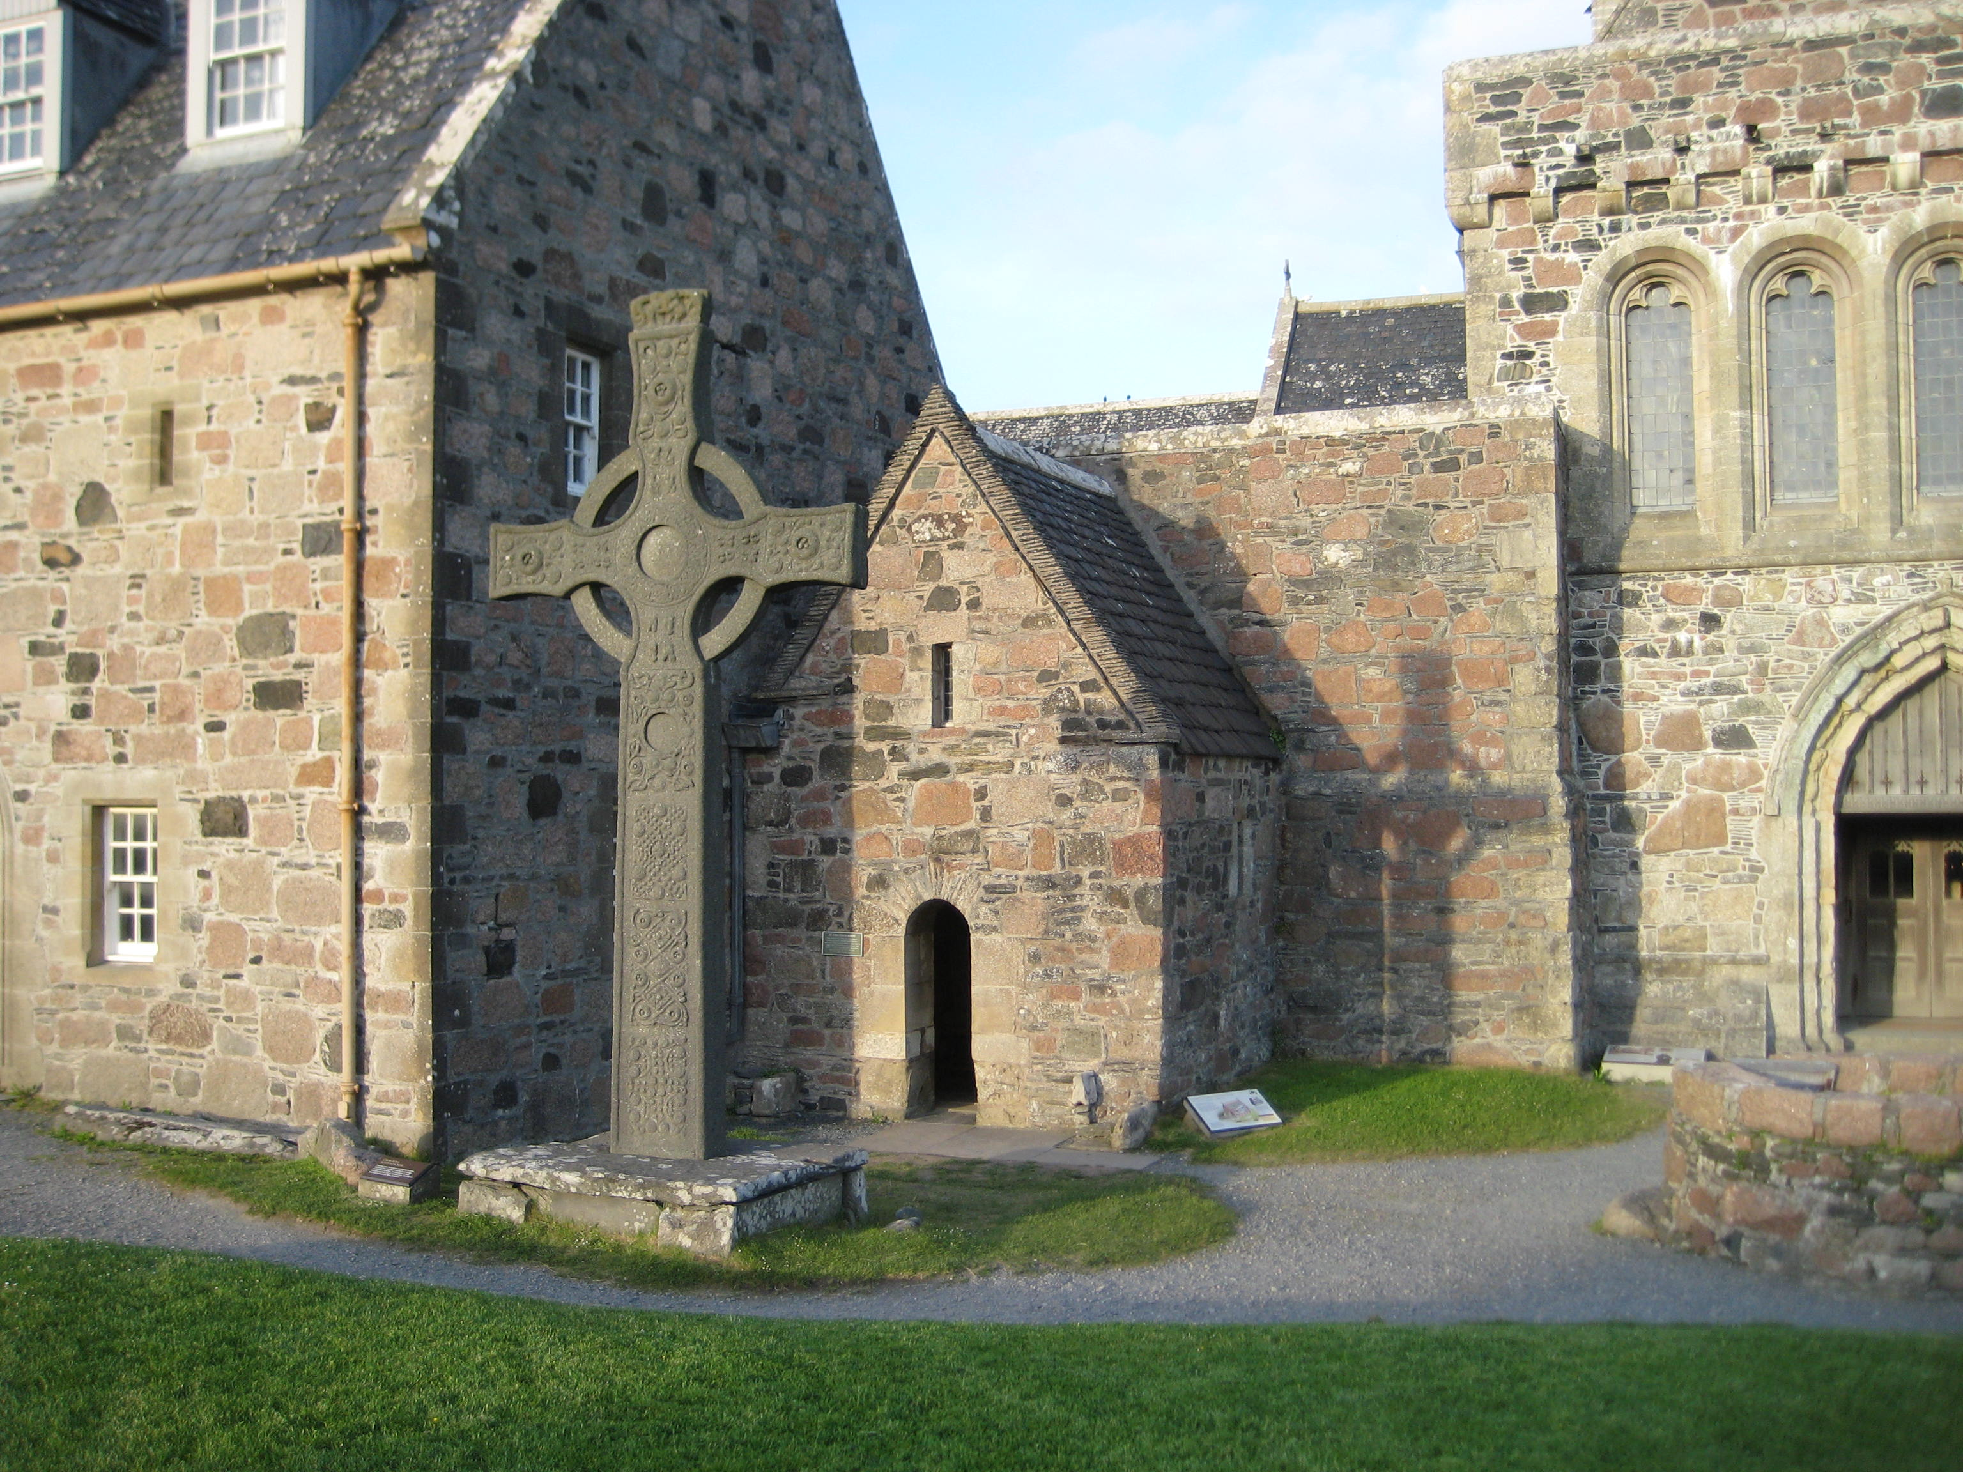

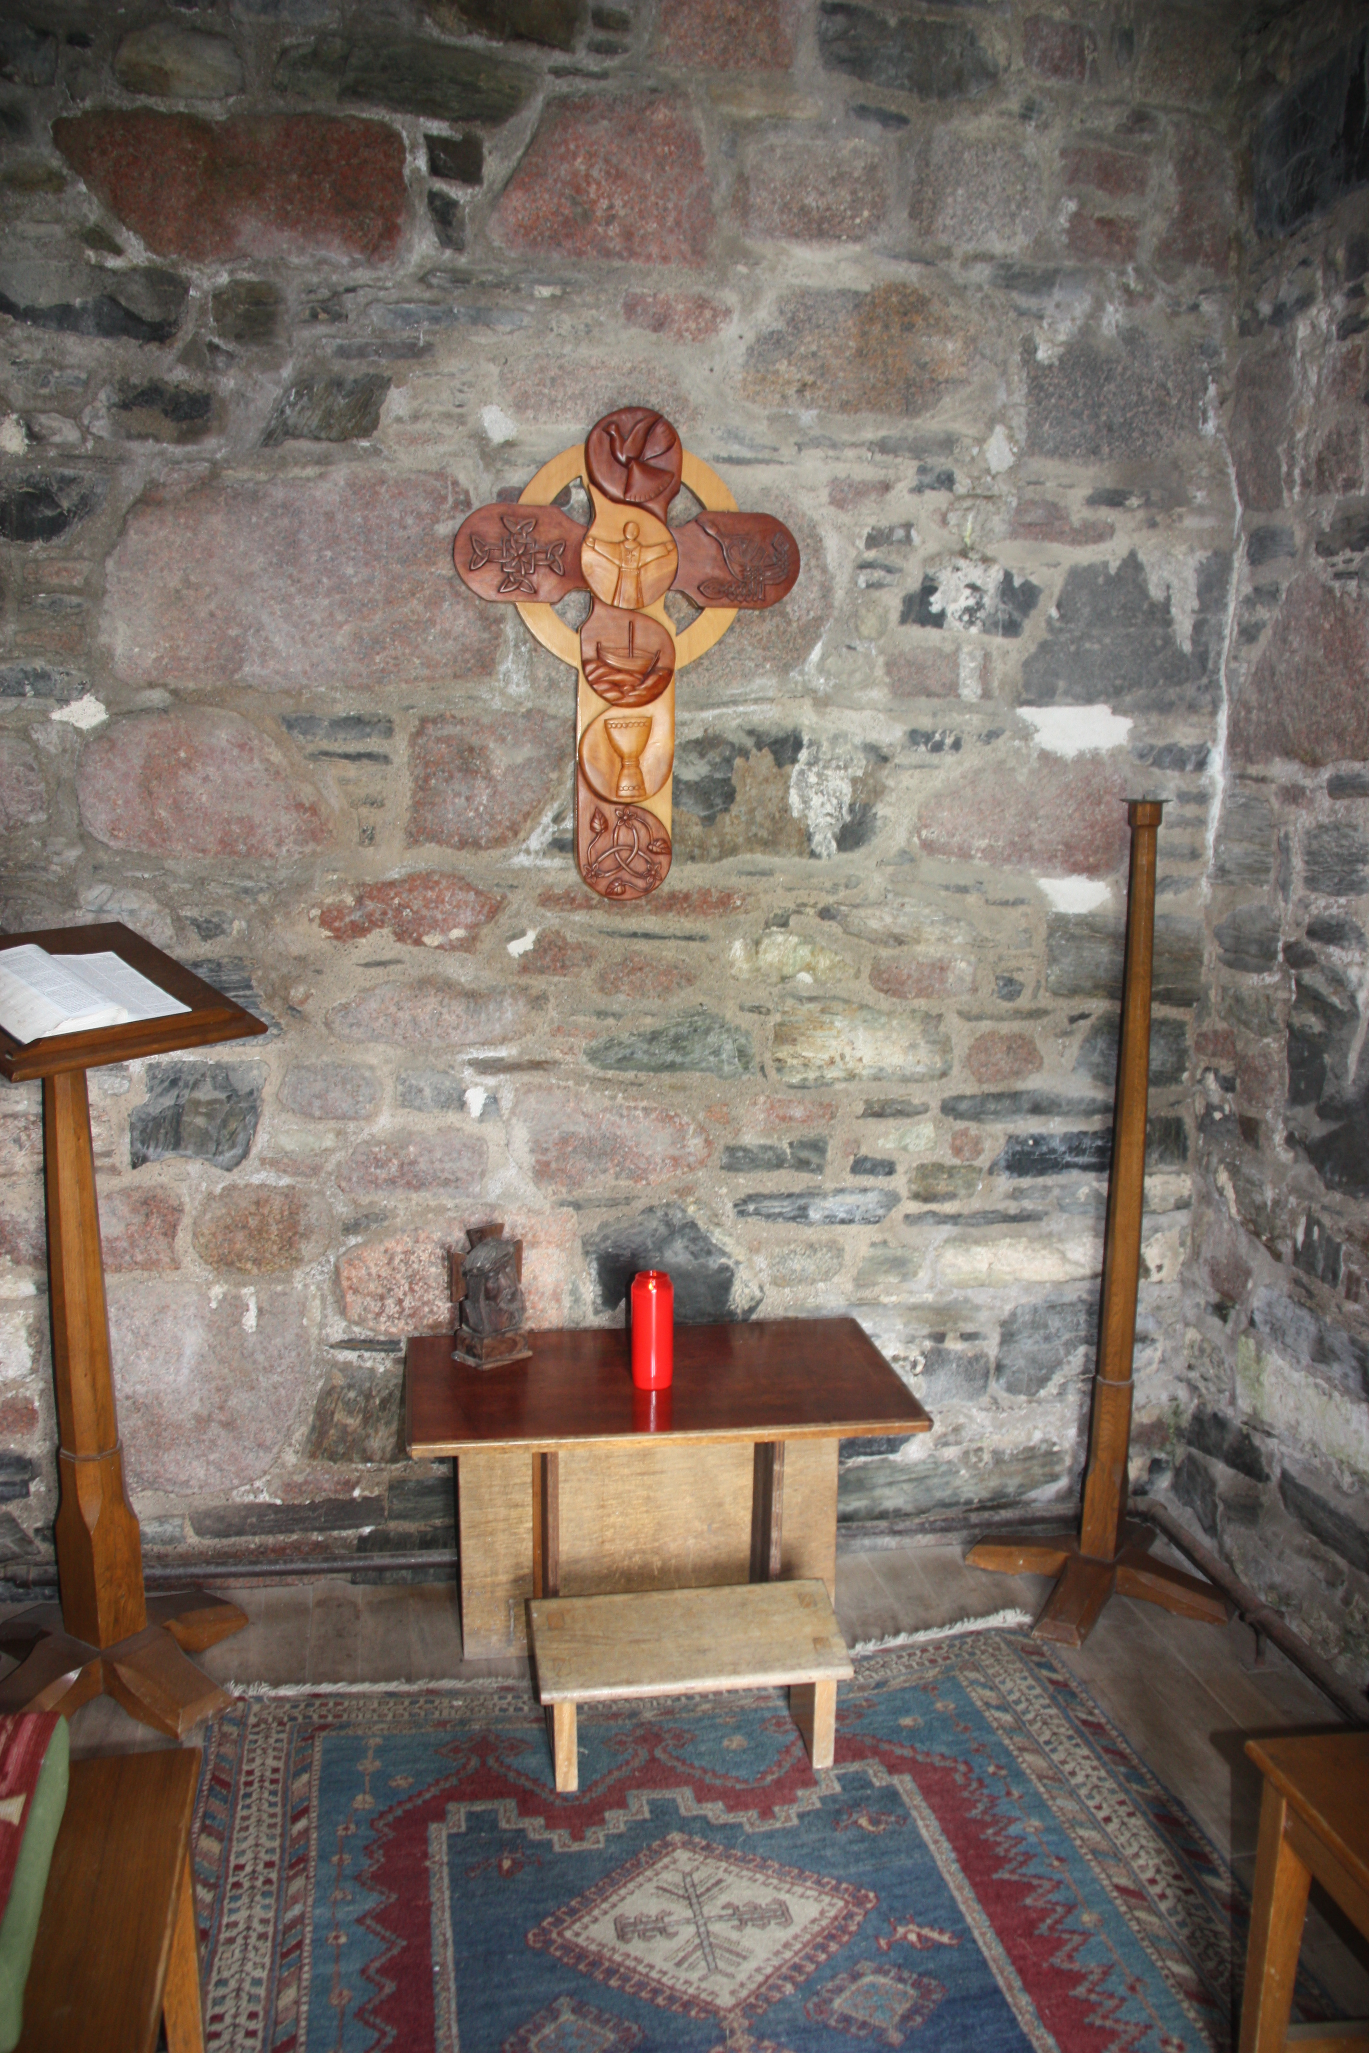

In this place of welcome, doors are opened, lights shine from the windows, and among companions we light a candle in the name of Jesus. (Iona Abbey Worship)

TWO PRAYERS

Prayers in difficult times

A prayer reflection
It's difficult to live with uncertainty.
However bad a situation,
knowing what you have to face
means that you can start coming to terms with it,
facing your fears,
planning your strategy.
When the 'big picture' is too big or too blurred
and indistinct,
it's easier to focus on small details,
to try to control what you can.
The world has changed,
how does that affect our living in the meantime?
How do I need to change?
How do I want to change?
Is it possible to live each day as a new opportunity,
while knowing that it feels the same as yesterday?
I need your help, God,
to listen for you in the clamour of voices calling for my attention,
to focus on you in the midst of competing priorities,
to trust you in this time of uncertainty.
Amen.

Prayers of Hope
Spirit of fire, warm us with your
everlasting love
Spirit of fire, warm us with your everlasting love.
Spirit of wind, blow away hurtful words that
damage relationships.
Spirit of earthquake, carry away our fears.

Spirit of breeze, restore our peace with your
calming breath.
Spirit of the living God, speak to us in words
we can understand.
Amen.

Roots on the Web

Appointment of CRCW

A new Church Related Community Worker (CRCW), Alison Dalton, has been appointed to the Sunderland & Boldon Partnership. We look forward to Alison joining us, and expect her to move into the manse at Roker within the next few weeks.

News Editor: Anne Anderson
Distribution: David Whiting

