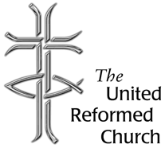
Stockton Road Church News
July 2020

5 Warnham Avenue, Grangetown,
Sunderland SR2 9PH
Tel 0191 549 9595

THE NEW NORMAL AND MISSION

Dear All,

In the last magazine I wrote about ‘Ready for the new “normal”’ produced by the Moderators as a discussion paper for recovery from the Covid-19 pandemic. Since writing, another document has been produced by the moderators entitled ‘Emerging into the “New Normal”’. Like the earlier document it has been prepared to help churches deal with the possibility of opening again. Among the issues discussed is whether churches should open for worship or not. It encourages churches to think about and plan the use of space. Other sections pick up on some of the same issues as the earlier document. As with ‘Ready for the new “normal”’ the new document can be downloaded from the United Reformed Church web site (www.urc.org.uk).

The companion document to the two referred to above is ‘New reality, same mission’. The booklet has been produced by a group of people including members of the United Reformed Church‘s Church Related Community Work, Mission and Discipleship teams along with Church Action on Poverty (CAP). It has been prepared to allow churches and individuals to explore various missional questions, including that of community presence and engagement,a and matters of social justice.

Some of you will be aware of the pastoral cycle. It is a tool that is commonly used for theological reflection. The booklet is structured around a version of such a cycle. It is a four-fold cycle: experience, exploration, reflection, action. We can begin anywhere on that cycle, so in practice it is more like a spiral.

You may have picked up on the experience of families who are hard-pressed struggling to find food to eat. This may lead to an exploration of what might be done in response to these people’s experience. You go on to reflect on what the will of God might be in this situation; this phase involves prayer and social analysis. Hopefully out of this springs action, maybe involving volunteering in a food bank set up by the church. The process then begins again as you learn more from the experiences of those involved in the food bank, perhaps learning about people’s economic or employment background; you are then back at the exploration phase again.

‘New reality, same Mission’ begins with a chapter on experience, picking up on poverty under lockdown, and visualising what is happening in neighbourhoods and communities. The chapter concludes with a possible action and some questions for reflection and discussion. Each of the subsequent chapters conclude with action points and questions for reflection and discussion.

The chapter on exploration picks up on matters of partnership and mutual support. We have an example of such partnerships within our own Partnership of Churches - Grindon Church Community Partnership exists in relationship with various community groups and partners.

Roker United Reformed Church has set up Roker Life, where Church is in partnership with several organisations including Social Chef and Forget-Me-Knot.

The third chapter is on reflection, and it opens with a noticeably clear question: ‘What does God ask of us?. We are then asked to reflect upon what we have to offer, which may be everything from space to prayerful support, encompassing things like pastoral support, financial and volunteer resources.

The chapter on Action gives some ideas for responses. It directs us towards Church Related Community Work, Walking the Way and the URC news pages. Walking the Way is about Missional Discipleship, which I have written about on these pages before, and in this Newsletter there is an article by Alison Dalton who will be moving to Roker this month as the Sunderland and Boldon Partnership’s Church Related Community Work Minister.

The final chapter is about action, and we are asked to turn our priorities into a plan of action. The chapter includes a quotation by Brian D McLaren who is an American Pastor involved with the emerging church movement. He describes himself on his own web site as an ‘author, speaker and activist’, he writes:

“In dangerous times like these … we have to produce generations of dedicated courageous, and creative contemplative activists who will join God to bring radical healing and change to this damaged world, before it’s too late. We need this movement – not someday, maybe, but right now, definitely” (quoted from ‘New reality, same Mission’ p.21).

Best wishes
David Whiting

Lectionary Readings July

5 - 11 July 2020 ‘Learn from me’
Zechariah 9.9-12; Psalm 145.8-14; Romans 7.15-25a; Matthew 11.16-19,25-30

12 - 18 July 2020 Once upon a time
Isaiah 55.10-13; Psalm 65 (1-8),9-13; Romans 8.1-11; Matthew 13.1-9,18-23

19 - 25 July 2020 A world of wheat and weeds
Isaiah 44.6-8; Psalm 86.11-17; Romans 8.12-25; Matthew 13.24-30,36-43

26 July – 1 August 2020 Secrets of the kingdom
1 Kings 3.5-12; Psalm 119.129-136; Romans 8.26-39; Matthew 13.31-33,44-52

From Alison Dalton, our new Partnership CRCW, who has already joined in on Zoom worship and meetings and we look forward to meeting in person soon.

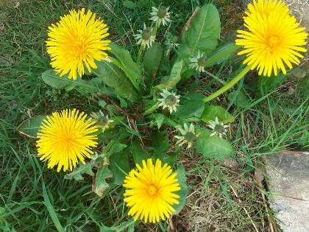
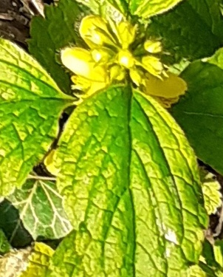
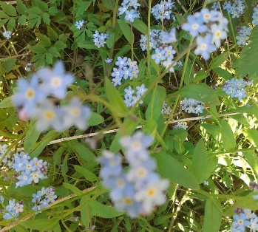
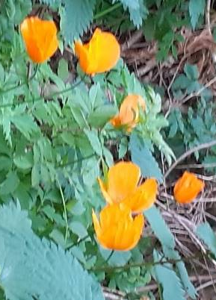

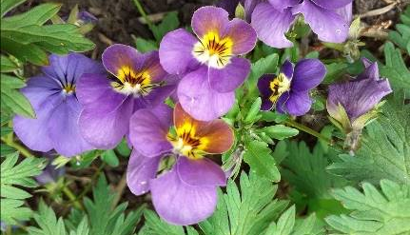
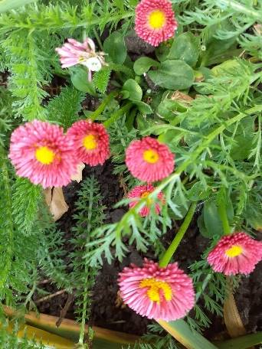
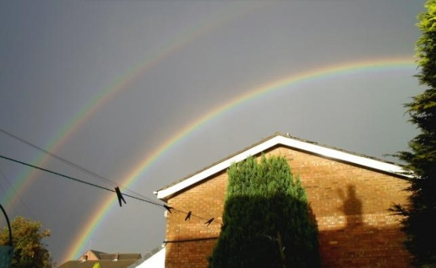
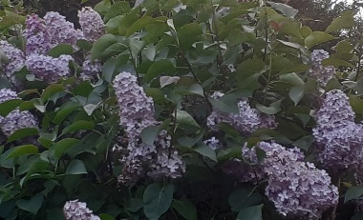

Nature’s rainbows, whimsical wanderings:
I’m writing this during week eight of lockdown, as things are beginning to be relaxed very slowly, very tentatively so it feels a natural time to reflect on these last eight weeks.
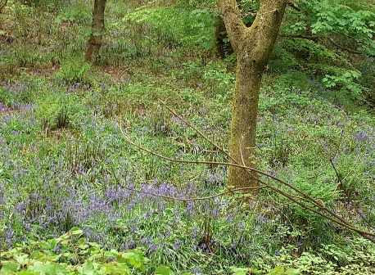
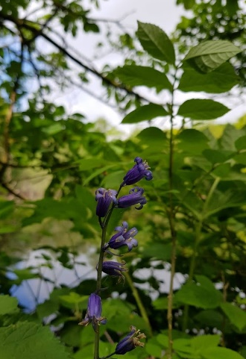
I am currently based in Tonge Moor, part of one of the more deprived council wards in Bolton. Tonge Moor is an urban area less than 3 miles from the town centre. However it has within or around it 5 rivers or brooks, the rivers Tonge and Irwell plus Astley brook, Bradshaw brook, and Eagley brook, which in turn means there is lots of walks near the water, covered by trees and undergrowth and so lots of nature if you are willing to look for it, often on the ruins of mills which nature has reclaimed as its own during the last one – two hundred years.
Over the last eight weeks I have made a conscious effort to use my daily exercise time to re explore this wonderful gift of green space, God’s creation and because of the time of year I have found myself watching the bluebells appear, first as a blanket of green and then as individual little blue bells and now I find myself amazed by the terraces of these lovely flowers there are to be found here!
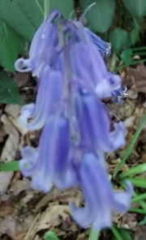
At the same time as I began enjoying this blanket of colour a resource for children to enjoy was shared on Facebook (https://m.facebook.com/spinnakertrust1/). This was an activity sheet based on the bluebell. It told me that the bluebell, historically, has many names, wood bell, fairy flower, cuckoo’s boots, lady’s nightcap. I can see why these names, can you?
This sheet also told me that in Victorian times flowers were given their own special meanings. The bluebell stood for humility, gratitude and everlasting love, for me a flower for this time.
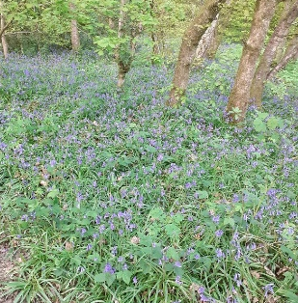
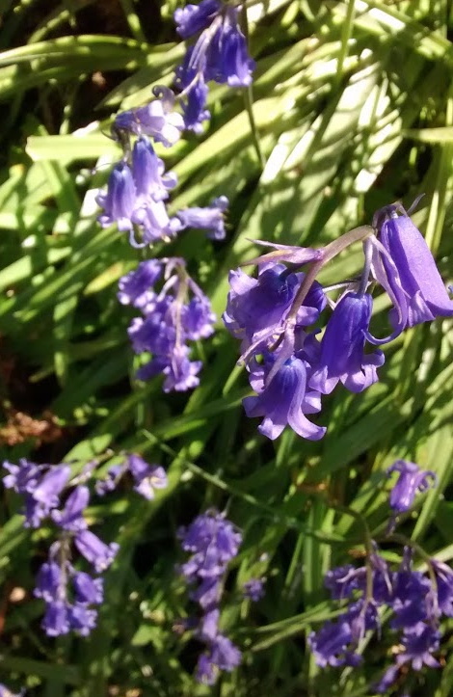
After all its first meaning humility remind us, perhaps, that humanity’s lack of humility may have been part of the reason for us to be in this situation we find ourselves in? Those that have been most important, most needed during this time have predominantly been those often missed, unseen and forgotten in our society, maybe we could say those working in the most humble occupations, the nurses, the home carers, the shop workers, delivery drivers, postal workers, transport workers, community volunteers.
Of course, that takes us to the second meaning, gratitude, which I don’t know about you but I certainly now find myself extremely grateful for all those mentioned in the list above, but also for so many other things. I find myself seeing God’s world, God’s creation anew, so grateful for the gift of this fine weather, for the technologies I used to moan about, for creative people trying new ways to keep us connected, for the time to reflect, review, and renew my spiritual life.
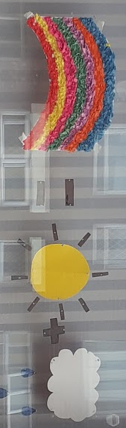
Again, that thought leads me to the third meaning for this unique flower, everlasting love! The love God has given and continues to give us no matter what mistakes we make, we just need to look at God’s creation to see the abundance of his love. The love you and I share each week when we clap our gratitude every Thursday at 8.00pm, or when we light our candle and pray for all those affected by this pandemic each Sunday at 7.00pm as requested by Churches Together in England. Not forgetting the love shared by our children, and some adults, when they paint their love and hope through the many rainbows placed in so many windows to brighten our days!
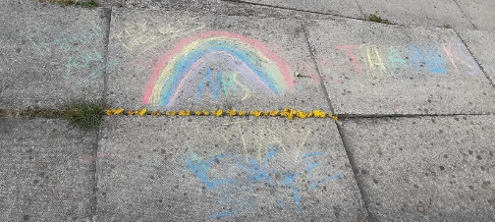
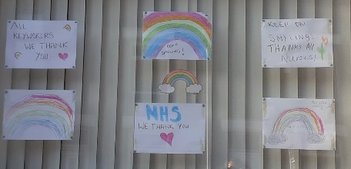
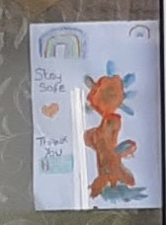
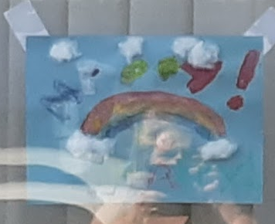
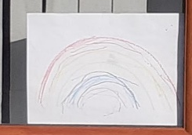
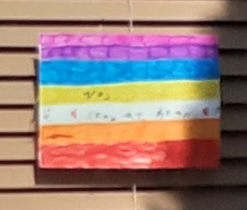
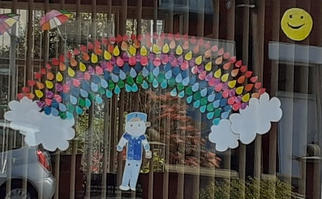
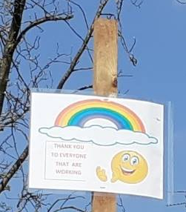
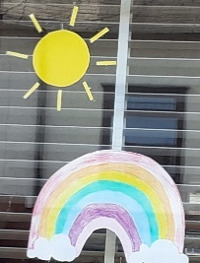
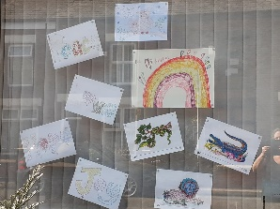
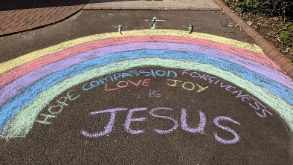
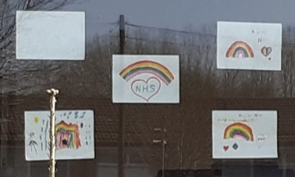
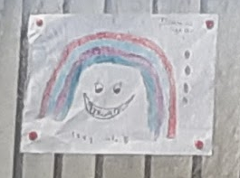

Emerging from Lockdown
The Elders have met via Zoom to discuss how to open up the church again. The URC and Synod have sent advice documents which will enable us to do risk assessments, identify what needs to be done and work out a plan.
Whilst we are keen to open as soon as is practical, we are mindful of everyone's safety and do not expect to open before August. We will keep you informed.

Church Alterations
Building work is continuing to progress smoothly so far, with the drainage work having been passed by the Buildings Inspector.
The projected completion date continues to be early August. After the builders have finished, there will be some moving of furniture back into place and cleaning required.

---ooOoo--

Every Tuesday, from March to October, the Iona community organises a pilgrimage around Iona, in which everyone is invited to join. The pilgrimage visits places of historical and religious significance on the island. At each place there is a brief reflection and prayer, sometimes with silence or songs.

IONA: THE ABBEY CLOISTERS

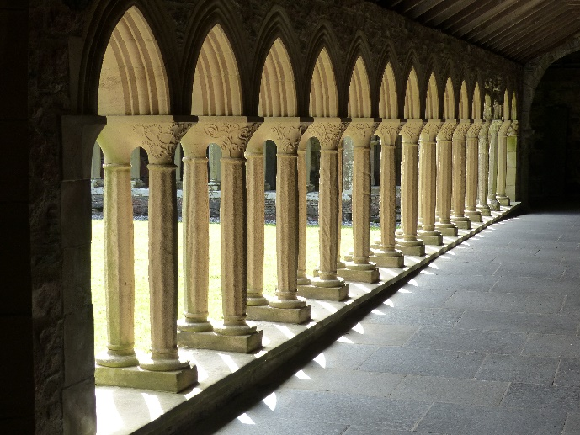

In 1938, the Iona Community began to rebuild the Cloister area of the Abbey buildings. The work was supported by friends from all over the world and completed in 1965.
Only two pillars remain from the Benedictine building. The Cloister carvings (below), by Christopher Hall, were commissioned in 1967 and depict plants and flowers of the Bible, flowers of Iona and of the British Isles, and birds of the West Highlands. The additional carvings, called Locks, illustrate the parables of Jesus Christ and also the offering of bread and wine.

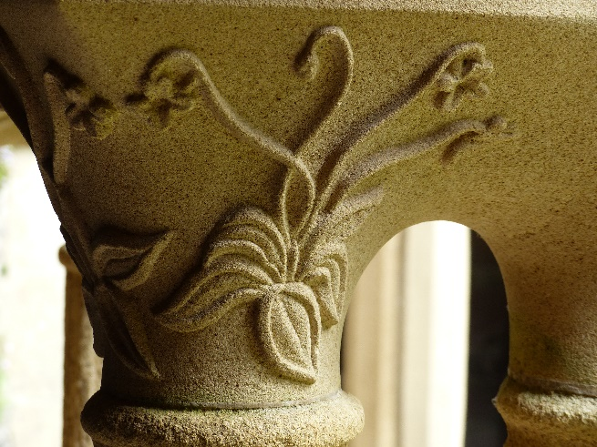
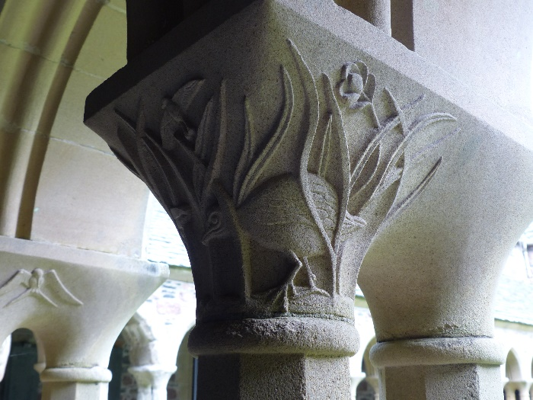
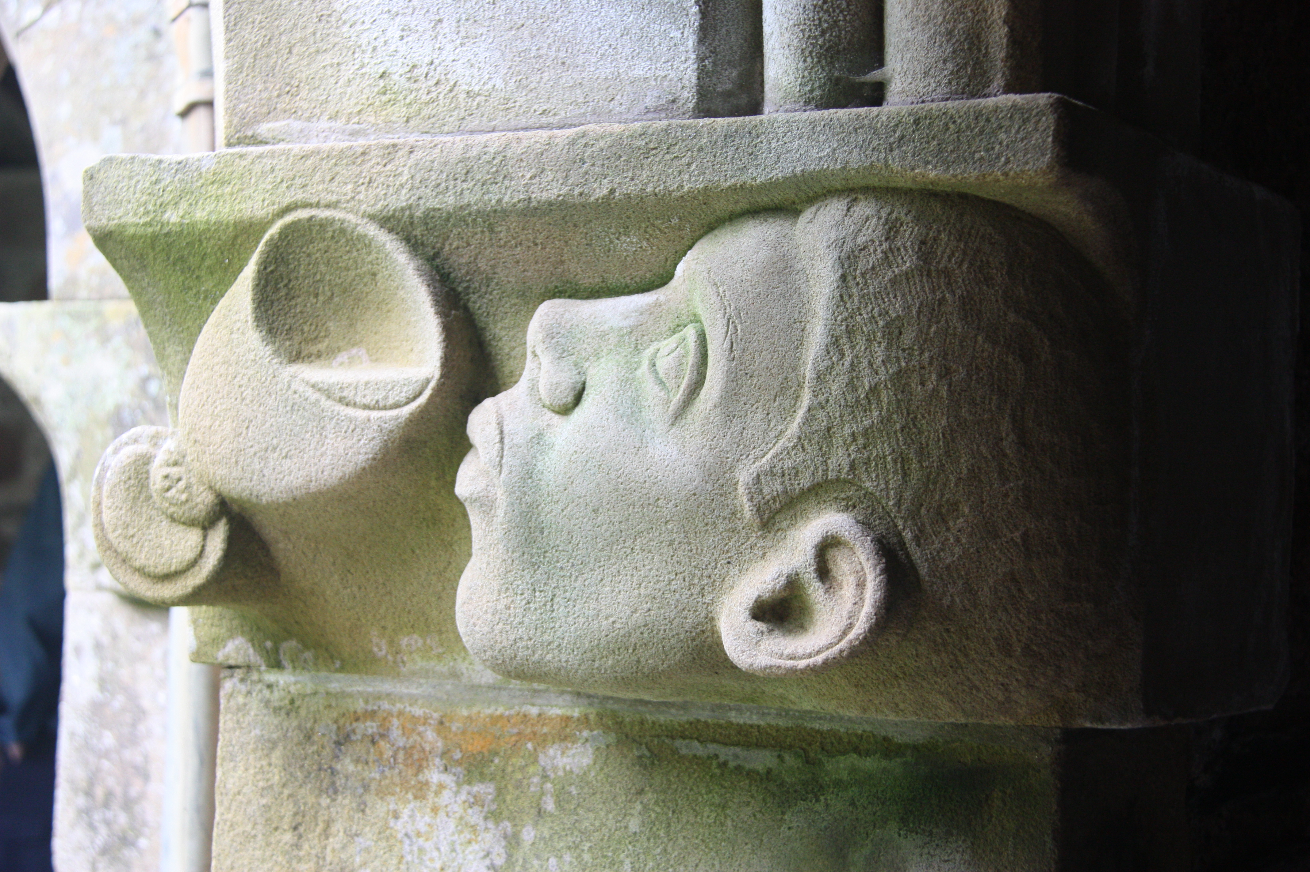

At the heart of the Cloisters is a sculpture by the Lithuanian Jewish artist Jacob Lipschitz, The Descent of the Spirit. The inscription reads, “I, a Jew, faithful to the faith of my fathers, have made this Virgin for goodwill among all people, that the Spirit may reign”. The sculpture, which can be interpreted in different ways, shows the Virgin Mary supported in a starry cloud descending to earth, represented by animals, birds and humans, and carried by the Holy Spirit, a Dove.
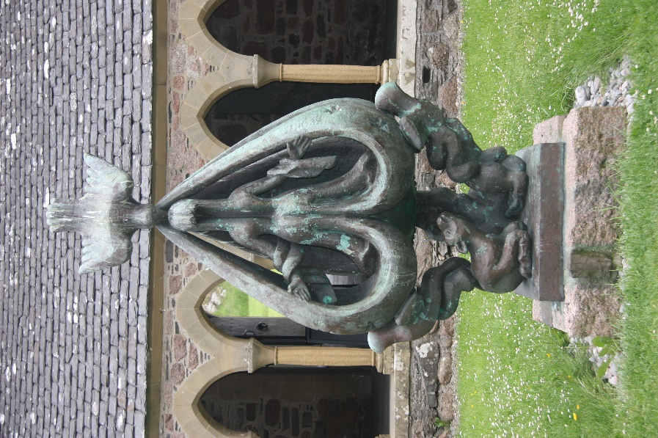

Cloisters have always been places where people can connect with each other. In this place we can be challenged to welcome and accept those who are different from ourselves.
“Carry one another’s burdens and in this way you will obey the law of Christ.”

Prayer

Gracious God,
You are welcoming God.

We come to you in prayer
And you are attentive to our needs.

We come to you in love,
And we receive your love.

We come to you in faith,
And you promise us salvation.

We pray for the world in which we live,
A world in which there is conflict and war.
We pray reconciliation and peace.
May we be peacemakers in the places we live.

We prayer for our churches,
At this time when decisions are being made,
Concerning stepping into the new normal,
Decisions about worship.
And hosting community groups.

May we be communities of welcome and hospitality,
Showing compassion in the big things and the little things we do,
May we provide healing and refreshment.

We pray for people we know who are ill,
We remember those who are ill, in hospital or at home,
Help us to show empathy and compassion.

Generous God,
Your Son said that whoever welcome him welcomes you,
May we not only open our doors.
But may our hearts and minds be opened as well,
May we be ready to provide even a glass of water to those in need.
In Christ's name we pray.
Amen

Please send copy for August edition by 19 July

Editor: Anne Anderson (rosina.anderson1503@ntlworld.com)
Distribution: Rev Dr David Whiting (david-whiting@hotmail.co.uk)

