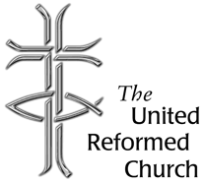
Stockton Road Church News
February 2021
5 Warnham Avenue, Grangetown,
Sunderland SR2 9PH
Tel 0191 549 9595

THE LORD’S PRAYER AND CORONAVIRUS

Lent begins this coming month on 17th February. One of the things I do during Lent is to buy a Lent book to read and to study. Sometimes I will read a couple of books, sometimes the book will be new sometimes it will be a spiritual classic from my bookcase. This year the book I have ordered is ‘Thy Will Be Done’ by Stephen Cherry and published by Bloomsbury Press. As the title suggests the book’s focus is the Lord’s Prayer. Stephen Cherry is currently Dean of Kings College, Cambridge, and if you watched the broadcast of ‘Carols from Kings’ before Christmas it would be Stephen who does the blessing at the end of the service.

Stephen Cherry was at one time working for Durham Diocese and we both had the privilege of being on the board of Lindisfarne College of Theology, or Lindisfarne Regional Training Partnership as it was known then. Coincidentally, I first met him when I was a student at Westminster College, Cambridge. I spent a week at one of the Anglican colleges, Westcott House, and Stephen was a student there at that time. I am not sure he remembered me when we later met up again.

On his blog ‘Another Angle’ Stephen wrote about his new book:

‘As I was writing the Lent Book, I was trying to imagine what we would be feeling about the coronavirus after the pandemic was over - anticipating that, by the time it was being read, lockdowns, masks and social distancing would have been mere memories. I couldn't have been more wrong.’

Despite this Stephen Cherry went on to indicate that he still thinks he was right to write about the Lord’s Prayer and pick up upon different interpretations for different times.

At the time of writing the book has not yet arrived through the post, but I was nevertheless left pondering what the Lord’s Prayer means to us during the time of pandemic and lockdown.

Most of you will be aware that there are two versions of the Lord’s prayer found in the bible. The one we know best is the version found in Matthew’s Gospel (Matthew 6:9-13). It is the one from which the prayer we pray perhaps daily is taken from. It is part of the block of teaching we know as the Sermon on the Mount and verses that proceed Jesus is teaching his disciples about prayer. The second version of the prayer is found in Luke’s Gospel (Luke 11:2-4) and it follows Jesus’ disciples request to him to teach them how to pray.

In the prayer we are praying to our God in heaven, and maybe simply doing that reminds that during lockdown when we feel perhaps lonely and isolated that despite the emotions we may be going through, that God is still with us, God remains open to our prayers.

The Lord’s prayer is prayer that is shared by Christians throughout the world, and praying that prayer binds us to others both in our country and throughout this world. We are not alone, even in lockdown, we don’t only have our own families with us, we are bound together with the whole Christian Church which is our worldwide family.

In his theological commentary on Matthew’s Gospel, the Methodist theologian, Stanley Hauerwas writes: ‘we learn to pray by following Jesus who is the Father’s prayer to us’ (Matthew, p.76). During the pandemic, we remain Jesus’ disciples, and we seek to follow.

We pray for the kingdom to come for God’s will to be done. Whatever that may mean it is prayer for hope. Not only are we living through Coronavirus itself, this pandemic also makes other crises in our world seem more vivid. We might think of poverty, racism, and other forms of prejudice and of course there is the underlying threat of environmental degradation, global warming, and species extinction. Praying of God’s kingdom mean we focus upon issues of justice and peace, in our prayers and in our accompanying actions.

The next two clauses about ‘giving us our daily bread’ and ‘forgiving us our trespasses’ or ‘debts’ as some translations put it, make us realise that there are many who pray for sufficient food, we only need think of the debates that have going on about the provision of school meals. Also, there are many for whom debt will be something that will hit them because they are unemployed, or their businesses have gone bust. We pray for ourselves, but we also pray for all around us.

‘Do not bring us to the time of trial’ we pray, and we know deep down we can and will survive this time for Christ has first gone through that trial through his engagement with the tempter and the cross, and he has been raised to life.

Earlier during this pandemic, Tom Wright wrote a book entitled ‘God and the Pandemic’. In one of the chapters, he asks the question about why must we lament? He points out that roughly a third of the psalms are psalms of lament, of things that are not as they should be, they show anger and frustration, sorrow, and bitterness. Tom Wright points out that the Book of Psalms was Jesus prayer book. Jesus not only uses these psalms, but we find lament in the Lord’s prayer. He writes:

‘The Lord’s Prayer is our ‘norm’. Are we looking for sudden signs of the End? No: we pray every day, ‘Thy Kingdom come on earth as in heaven’, and we know that prayer will be answered because of what we know about Jesus’ (God and the Pandemic, p.53)

May God be with you.

David Whiting

Lectionary Readings February
31 January – 6 February - Making an impression
Epiphany 4: Deuteronomy 18.15-20; Psalm 111; 1 Corinthians 8.1-13; Mark 1.21-28
7 - 13 February - The first 100 days
Epiphany 5: Isaiah 40.21-31; Psalm 147.1-11,20c; 1 Corinthians 9.16-23; Mark 1.29-39
14 - 20 February - Wow!
Transfiguration: 2 Kings 2.1-12; Psalm 50.1-6; 2 Corinthians 4.3-6; Mark 9.2-9
21 - 27 February - Beloved
Lent 1: Genesis 9.8-17; Psalm 25.1-10; 1 Peter 3.18-22; Mark 1.9-15
28 February - 6 March - Rocky relationships
Lent 2: Genesis 17.1-7,15-16; Psalm 22.23-31; Romans 4.13-25; Mark 8.31-38

A letter and prayer from Church Leaders in the North East for the Week of Prayer for Christian Unity – 18 January 2021

Dear brothers and sisters,

In normal times we have been able to celebrate the Week of Prayer for Christian Unity by sharing worship together and being enriched by each other’s traditions. This year of course this is not possible but just as moving to worshipping online does not mean our churches are closed, our prayer for Christian Unity is alive and vibrant and we pray this may be a sign of hope in our world.

We are very mindful that all us are currently faced with many challenges, as we seek to worship together safely, provide care for those in need, and share the good news of Jesus Christ.
In this Week of Prayer for Christian Unity, we assure you of our prayers for all of the churches in our area, and of our commitment to our partnership in the Gospel as we all walk together during these times of anxiety and grief. May all of us know the hope which is found in Jesus Christ as we share his love with the communities we serve.

A prayer for Christian Unity

Lord, you invite us to share together in your love.
You call on us to see the beauty of each other’s expression of the faith,
and to see the unity beyond the differences that can make us afraid.

Fill our hearts with the love of you, and make us new again.
Open our eyes afresh to our part in your love for the world,
that as one body we may sing your praise,
serve the needy, and seek the lost.

Amen

Lent Resources
These packs would be suitable for old and young alike and something we may want to buy for our friends or ourselves. A great way to show people we still care even though we are physically unable to be together

Walking towards Easter together URC LENT Resource 2021.
We are delighted to offer a Lent resource for churches to give to students, seniors, households and families to reduce isolation and offer hope in these challenging times.
The pack invites them to join a journey through Lent with opportunities to build connections with Jesus, others and their local church. The materials include a wide range of activity suggestions so there should be something for almost everyone to engage with in their own home. Contents: A3 poster – a map from Shrove Tuesday to Easter Sunday 250 stickers to use with the map and journal A5 spiral bound stand-up diary/journal with pull out activity pages. Each day take a step towards Easter – mark your way on the map, use the creative diary/journal and dip into the activity suggestions: cook * make * give * pray * connect * think * do * discover * share * challenge * dream * play * smile * thank.

Diary includes: Monday to Saturday read a real life story of someone walking the way of Jesus, reflect on a Bible verse, and use the space provided to record something of your day. Sunday pause to engage with a story about Jesus, a reflection and some suggested ways to pray, with space to record your responses
Holy Week create a garden and follow the final few days leading up to the cross and tomb.
Easter Sunday celebrate new life: faith hope and love restored.
The Sundays use the same readings as ‘Holy Habits: following Jesus by Andrew Roberts (BRF Lent resource for 2021)’.
Alongside this, we will produce an online guide for churches with suggestions for how to connect those receiving the Lent resource with the wider life of the church. Price: £4.50 plus P&P each and all orders must be placed through the URC Bookshop https://urcshop.co.uk. Dispatched first week of February.

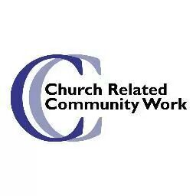


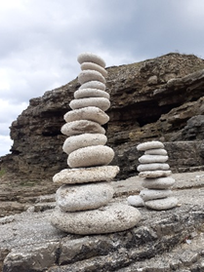

Thinking Allowed!

I’ve been mulling over this piece for over two weeks now, wondering what to write. Of course, this is the first newsletter of 2021, so I automatically thought about wishing you all Happy New Year and to consider the new beginnings that offers us. However, that feels a difficult thing to consider in these dark times, times that many of us are finding hard, times we are in the middle of and times when it is hard to plan. Perhaps it is all we can do to get through each day as it comes…
This Photo by Unknown Author is licensed under CC BY
Then I was out walking early evening, I often pray as I walk. So here I was asking God to help me work out the theme of this piece when I found myself noticing the sky. On a previous walk I had been wondering about a theme of light and dark as these times feel so dismal and dark but that felt rather passe to me, I’m sure you would all have heard any perspective I could bring to this theme before!
Perhaps God was helping me to build on that earlier thought because as I looked up at the sky it struck me how, even in the evening sky, there are dark and light hues, not just caused by the clouds but by our human impact.
We often talk about the night sky just being dark, midnight blue, perhaps a consistent block of colours sprinkled with stars. However, on this particular evening, when you looked closely, that was not the case. You did have to look very closely but if you did it became clear that out to sea there was obvious blocks of darkness but as I looked along the coast there was a lightness probably caused by our human impact from street, work and from home lighting.
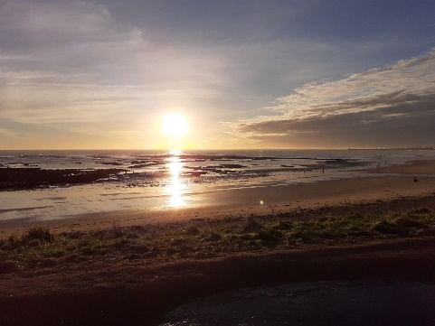
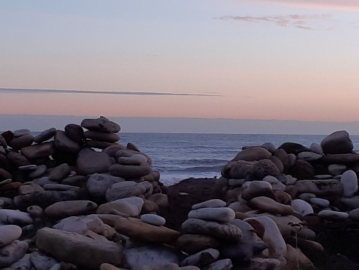
This reminded me of a recent early morning walk to the labyrinth as the sun was rising, the sky had a more distinct mix of light and dark, of hope and expectation, or despondency and despair.
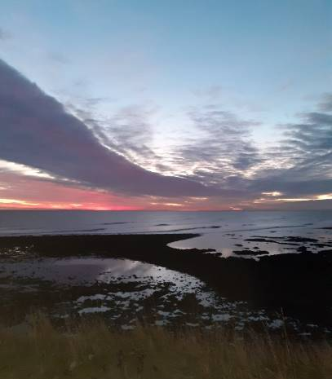
I then remembered sitting in the labyrinth the week before, this time it was sunset not sunrise, the sky was beautiful, full of hope and possibility even though the darkness was coming. It struck me how the walls of the labyrinth depended on the pebbles balancing on top of each other to make these walls, sometimes, it seemed to me, so precariously, but still serving a critical purpose in this construction allowing it to be used by people like me.
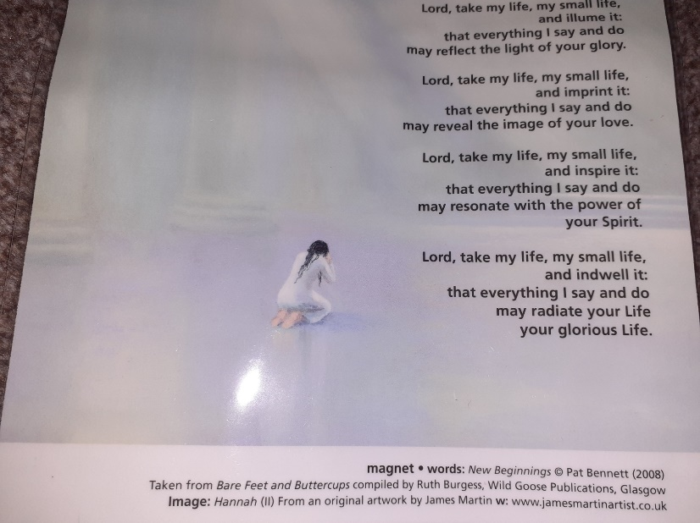
What does all this mean, well my thought process told me that we need light and dark, hope and despair, that that is just how life is. We need both hope and despair to see the real richness our life offers us, even if we have already had a long life. We are being asked to continue to grow in the life God has and continues to give us. However, we need a balance within all of that possibility the reality of being able to cope. How can we achieve that in times like this? For me, my belief, my understanding means that that balance has to come from within us, hard as that may be. It needs to come from our understanding and from our relationship with God, the relationship that only we as individuals can develop ourselves.
Just before Christmas, when I was developing the prayer spaces for some of us to pray in a carefully open church, I found this image which I thought may be relevant to this piece and guess what, I think it is.
It says:
Lord take my life, my small life, and illume it:
that everything I say and do may reflect the light of your glory.
Lord, take my life, my small life, and imprint:
that everything I say and do may reveal the image of your love.
Lord, take my life, my small life, and inspire it:
that everything I say and do may resonate with the power of your Spirit
Lord, take my life, my small life and indwell it:
that everything I say and do may radiate your Life your glorious Life.
Amen

I hope and pray that you stay safe and continue to look to God for solace and care in these difficult times.
Best wishes
Alison.
Church Related Community Worker,
07908110121, crcw.alison.dalton@gmail.com

Copy for March Newsletter by 21 February please to
The induction will be filmed on: 26th of September 2020
At: Roker United Reformed Church,
Sunderland SR6 9JP
This will be released on You Tube for any who choose to join us,
to worship with us, as we celebrate our ongoing journeys together and apart, by the 7th of October 2020
https://www.youtube.com/channel/UCFgX-JjMdJk8UqMWCZCDfXg
Editor: Anne Anderson (rosina.anderson1503@ntlworld.com)

